Google Maps Website/App

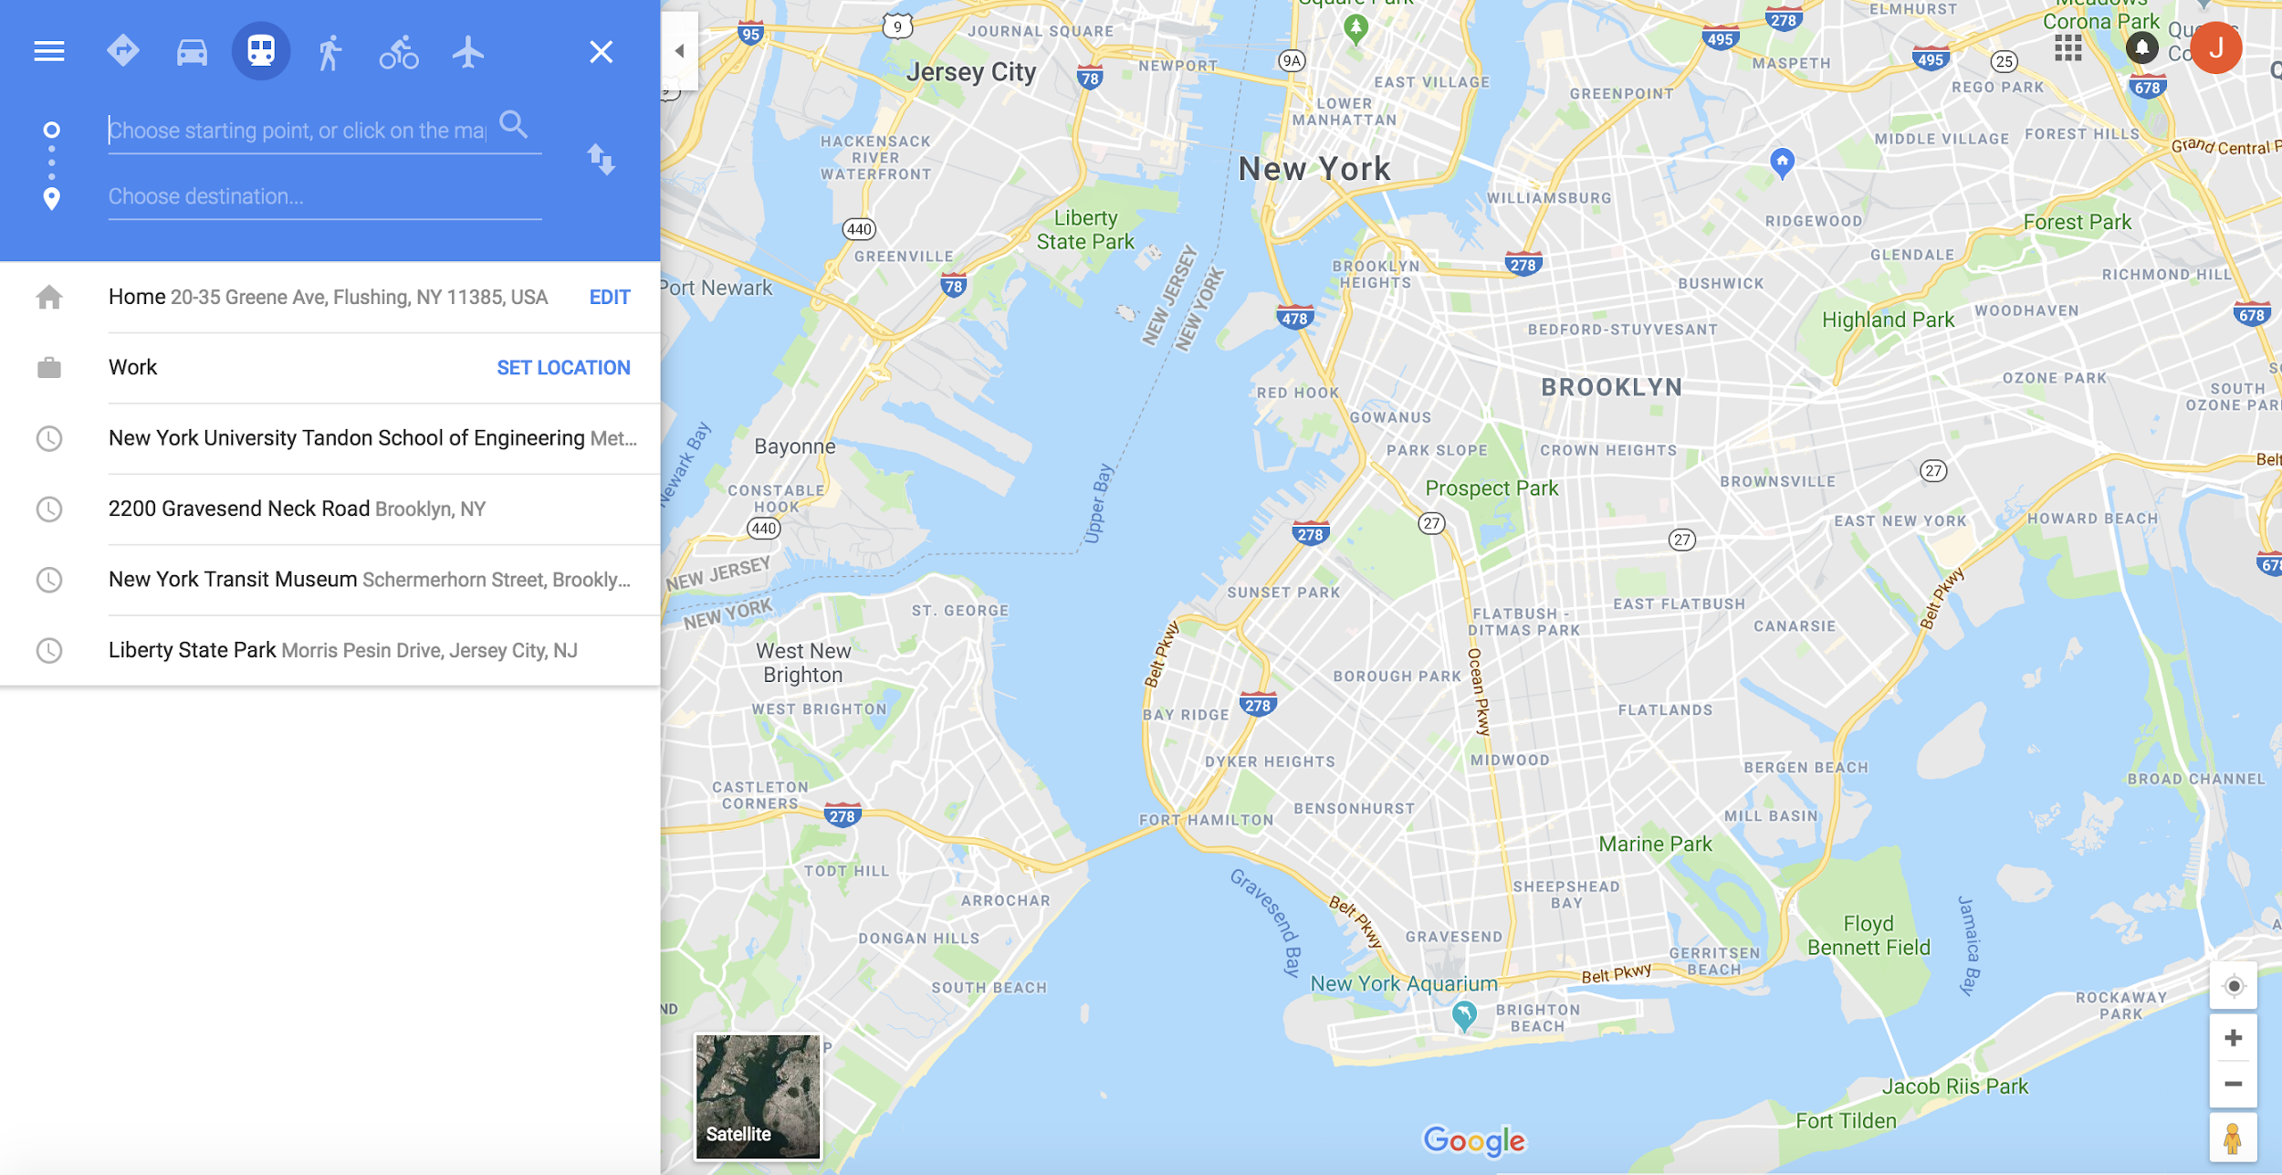

Click here for the direct link to the website.

Sample search for the destination you wanted to go to showing the number of train hops.

