Rate, Functions and Equations in the Real-World

Name:_____________________________Class:__________Date: _________

Subject Ms. _______________________

Problem

How fast does a message travel over the network before reaching its destination?

Hypothesis
What do you think will happen?
Write your hypothesis in the “If…(independent variable), then…(dependent variable)” format?

If __________________________________________________________________________________________________________________________________

then __________________________________________________________________________________________________________________________________.

Materials:
COSMOS toolkit
- Post-it Chart Paper
- Markers
- Pencils
- Globe
- Google Map on Phone/Computer
- Subway Map
- Strings
- Push pins
- World Maps
- Graph Paper

Procedure
Pre-lab preparations
- In your group, decide which job each person will have
  - Timer: __________________________________________________
  - Data Recorder/Program Runner: _______________________________________________________
  - Facilitator_______________________________________________
- Set-up the COSMOS Toolkit
- Check if the toolkit has all its complete set-up: antenna, SDR receiver and the monitor.
- Put the whole thing in a stable surface like a table.
- Have papers/graphic organizer ready for recording results.
- Make sure you have the Globe or the world map in front of you.
- Phone used to take a picture of what’s visualized on the screen or make sure the laptop will be used to take screenshots of the various things you need to capture.
- Discuss how you will orchestrate the whole process or create a system where you can perform the whole process within the allotted time.
- Perform the experiment when your teacher gives you the signal to start.

Part A- Activity Using the Subway Map and the GPS on the phone or computer:
- Students will use the Subway map to trace how many hops they will take to go to a certain destination.

Example: Going on a Fieldtrip

Starting Point: PS 206 at Gravesend Neck Road, Brooklyn, NY 11229
End Point: Bronx Zoo

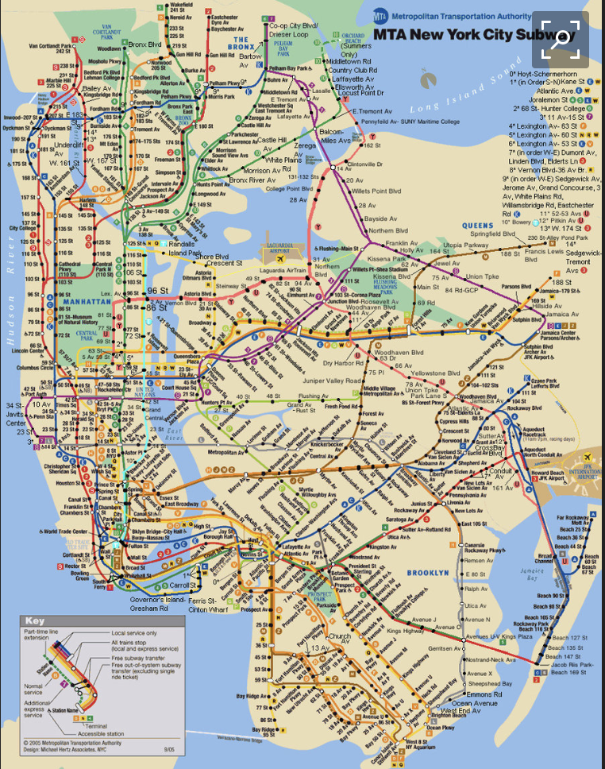

Using a Google Map to go to a location through a subway will give them this data:

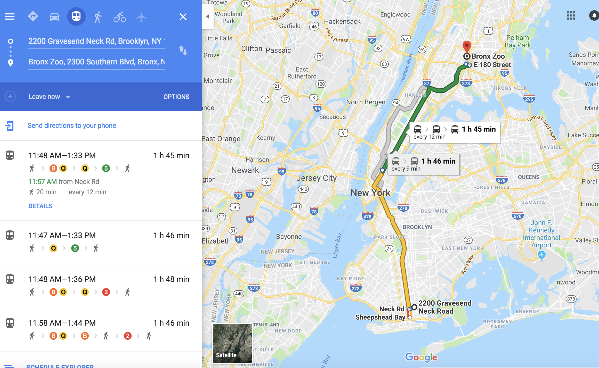

Graphic Organizer

Starting Point | Destination | List of Hops or Stops | Time  (minutes) | Distance  (Optional)
PS 206 220 Gravesend Neck Road, Brooklyn, NY 11229 | Bronx Zoo, 2300 Southern Blvd, Bronx, NY 10460 | Trip Option 1:  Trip Option 2:  Trip Option 3:  Trip Option 4:

Show on the graph the relevance of time and distance travelled using the different options you took.
Use different colors to show the route of different options you can take and indicate that in your graph KEY.
Questions:

- What do you notice about the data you collected?
______________________________________________________________________________________________________________________________________________________________________________________

- Based on you graphical data, what can you conclude about the relationship between distance and time of the different options you can choose from?
_________________________________________________________________________________________________________________________________________________________________________________________________________________________________________________________________________________________________________________

Part B- Activity: Use a traceroute to see how traffic is transferred between Internet Service Providers

Vocabulary Words:
AS-
ISP-Internet Service Provider
GTT Network-
CDN -Content delivery network

In this activity, we will use a tool called a traceroute which shows us how messages are passed between our computer and a content provider.
For example, consider the path between my laptop and the Washington Post website. To view the path, I will open a terminal and run
mtr --aslookup -t washingtonpost.com
The output may look something like this:
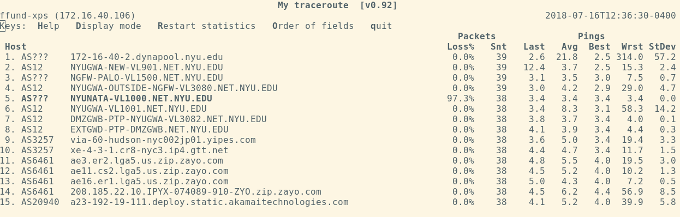
I can see that the traffic originates in AS12 (New York University’s network), then is passed to AS3257 - GTT Communications. I can further infer from the hostname at that point that the message is transferred to GTT’s network at the IXP at 60 Hudson Street in NYC.
From there, I can see that the message is passed to AS6461 - Zayo, and then to AS20940 - Akamai, which is the content distribution network used by the Washington Post.
If the network that I am located on changes - for example, if I tether to my cell phone network - I can see that the route changes:
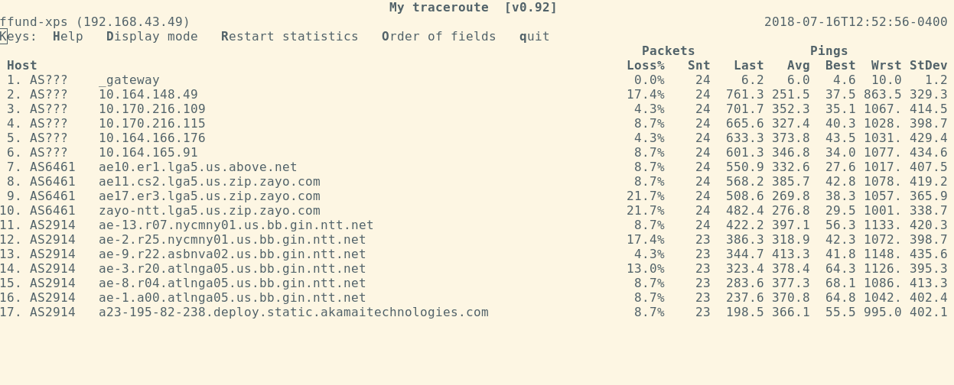
In fact, even though I’m visiting the same page, I end up at a different destination! In this case, I ended up at an Akamai server whose internet service is provided by AS2914 - NTT America.
I can change the name of the webpage to trace the route to other locations. For example, I can run
mtr --aslookup -t ucla.edu
And see the path between NYU’s network and UCLA’s network:
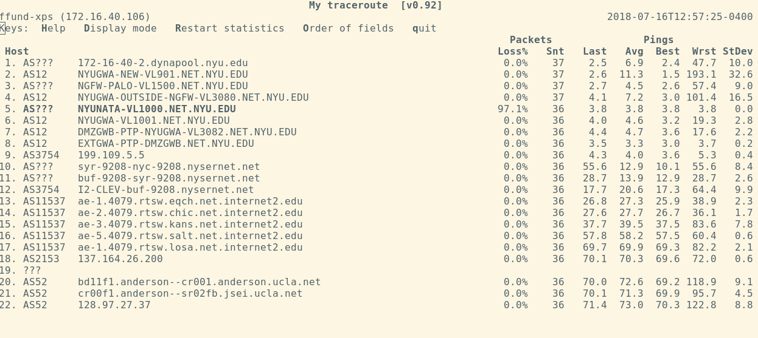
For this activity,
- Use the traceroute tool to view paths from your laptop to different destinations. Look up the details of the ISPs along the network path. (Note: NYU’s guest network and eduroam network may block the kinds of traffic needed for this tool to work, so make sure you are connected to the regular NYU network.)
- Try changing the source network that you are on - for example, by tethering to your cell phone, or by running the traceroute tool from a host somewhere else on the GENI network. (See appendix at the end for a list of GENI nodes you can log in to at different sites.)
- Can you identify specific cities along the route? (Try a site hosted abroad, e.g. ethz.ch).
- Can you identify specific Internet Exchange Points at which traffic is exchanged?
- Can you identify specific CDNs that host traffic for websites you visit?
- What is the largest number of ASes traversed for one end-to-end path? The smallest? Do you observe an effect on end-to-end delay?

Part C
- To start today’s activity, I want you to think about the places where you want to visit outside the United States or Universities you wanted to visit.
Example:
-Columbia University
-Binghamton University
-Stanford University
-Yale University
-Duke University
-University of Texas
-Wisconsin University
-UCLA
-UNLB

Vacation:
- Cultural Heritage in China
- African-American Museum
- Yellow Stone Park
- Vatican City
- Eiffel Tower in France
- Bahamas

https://traceroute-online.com/

Example:

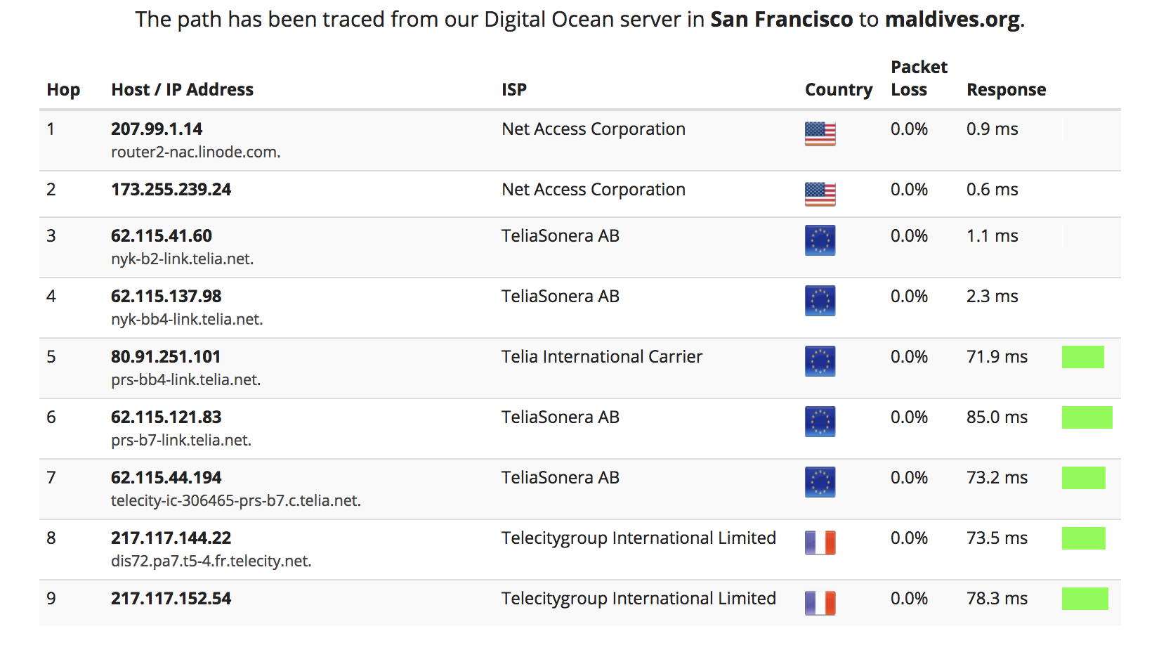
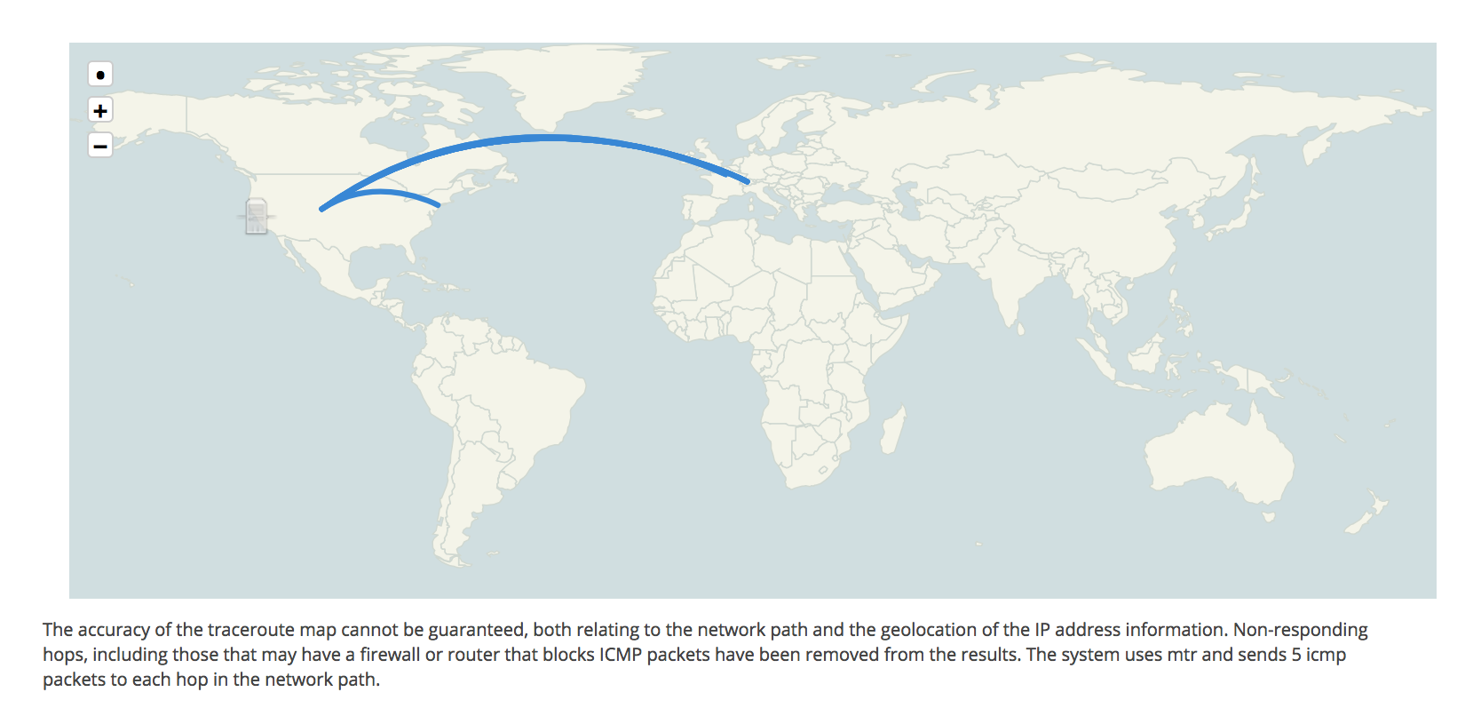
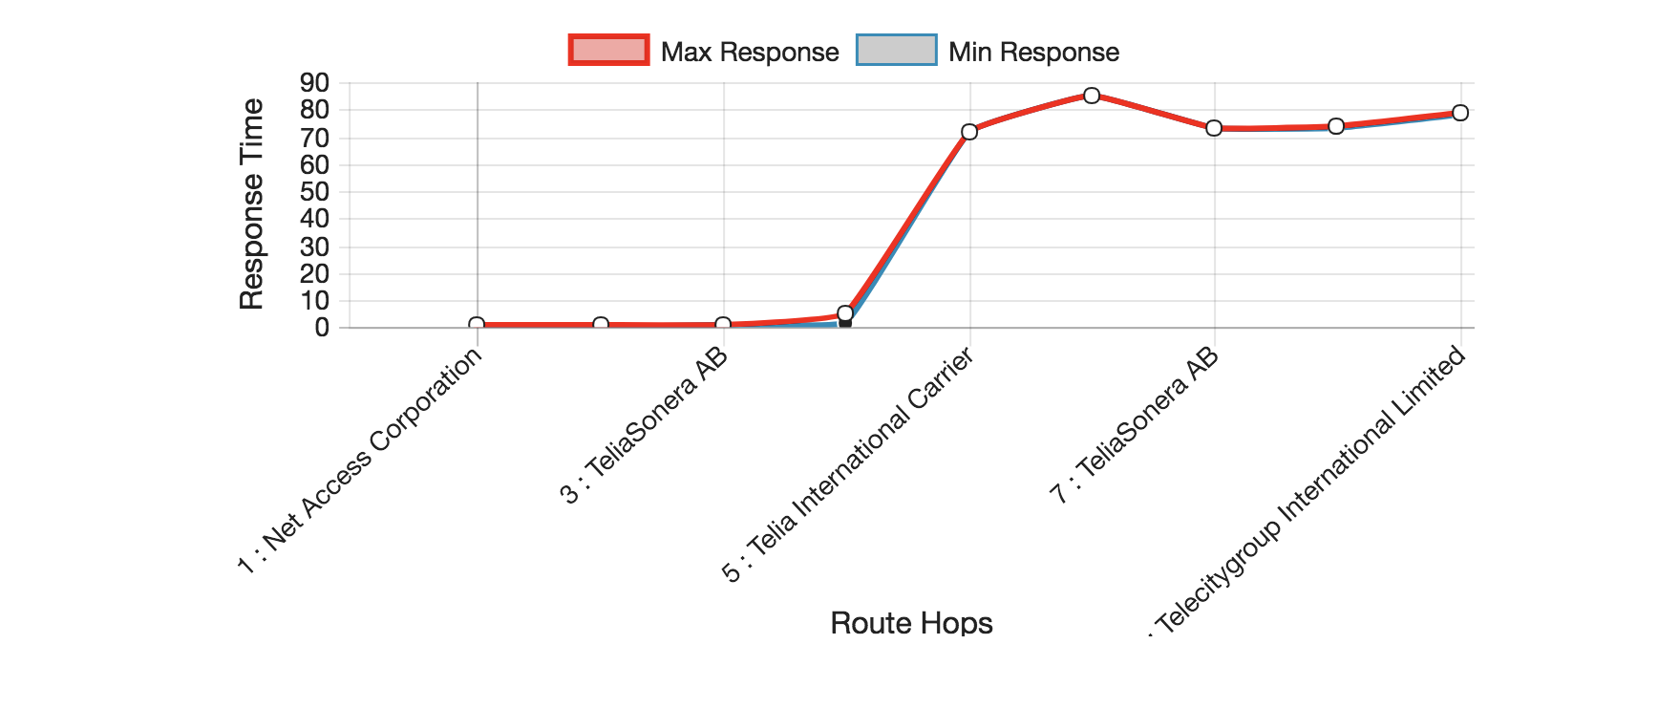

Show the number of hops and internet service providers it takes in your research before you find the exact webpage.

Indicate this on the world map using the strings and the push pins.

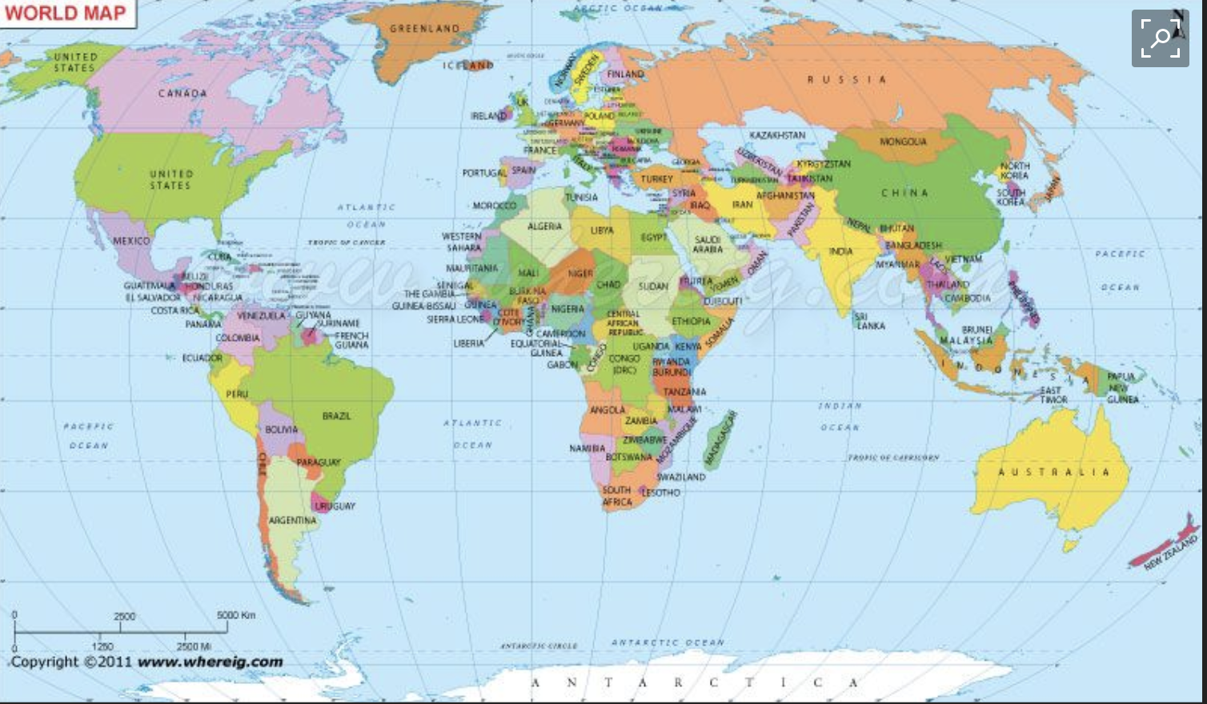

- What do you notice about the data you collected?
___________________________________________________________________________________________________________________________________________________________________________
- Based on your data shown on the world map, what can you conclude about the relationship between the number of hops and internet providers to the distance and time it takes for a message to arrive at a particular destination?
_________________________________________________________________________________________________________________________________________________________________________________________________________________________________________________________________________________________________________________
__________________________________________________________________________________________________________________________

Reflection
Think about your experiment!!
Your discussion must be detailed and include answers to the following questions:
- How did your data from part A, part B, part C the same?
- How is the data from part A, part B, part C different?
- What are some factors that could’ve led to differences among the three parts?
- Do you feel the data is valid (reliable and accurate)? Why or Why not?
- What were the sources of error in this experiment (factors that may have affected your results)? Explain.
- If you had the opportunity to redo the experiment, what changes would you make? How would you improve it? Explain.
- What new questions did the experiment generate? Explain.
- What did you learn from the experiment? Explain.

