Student Name______________________________________ Class_________

Analog Wave Signals Lesson 4

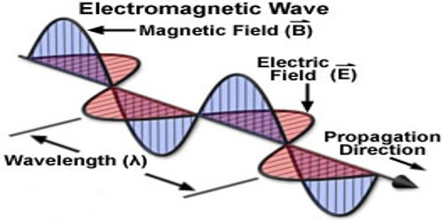
An electromagnetic wave consists of an electric field and a magnetic field that travels through the air (matter) or space. If you can generate an electric field and a magnetic field, then you can create an electromagnetic wave. Electromagnetic waves travel at the speed of light: 299,792,458 m/s. They can travel long distances through air, through space and many materials.

Whenever we use a wireless transmission to share information it is done with an electromagnetic wave. Any set of information can be an information signal. For example, the different temperatures through the day would be an information signal, and when you write a text, the letters of your message is an information signal. Informational signals are translated into electromagnetic waves and transmitted to other receivers somewhere else.

Information signals can be represented in two major forms: analog and digital.

Analog Signals
Signals that vary all the time and can have different values all the time are called analog signals. The transmission of analog signals is subjected to deterioration by noise. That is why analog signals often sound scruffy and not clean. Analog requires only a small bandwidth.

Examples in Real Life
Think of a regular (analog) thermometer and a digital thermometer. With the regular (analog) thermometer one would often not be certain as to the exact reading of the temperature. However, with the digital thermometer the reading is displayed with specific digits giving a definite reading.

Modulation
The process of transforming an information signal into an electromagnetic wave carrying this information is called modulation. When we modulate an information signal we vary one or more of three properties of a wave (amplitude, wavelength, phase) to represent the values of the information signal.

The 2 most common types of modulation are Amplitude Modulation (AM) and Frequency Modulation (FM). Both are used for analog signals and digital signals.

Analog Signals and AM
Consider an information signal wave that looks like this:
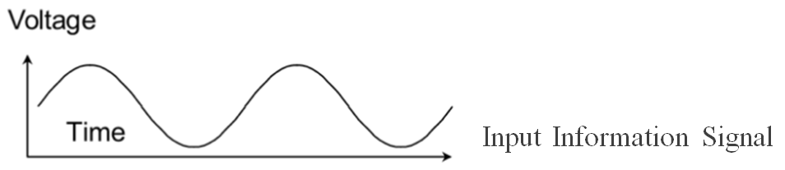
This information signal has to be carried on a carrier wave with a higher frequency like this:

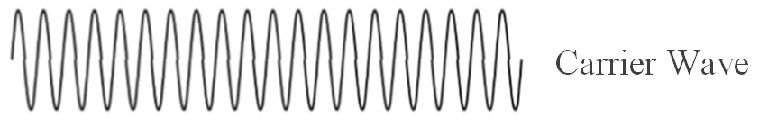
To carry the signal using amplitude modulation, we will vary the amplitude of the carrier wave according to the values of the information signal. So the AM signal that is transmitted looks like this:
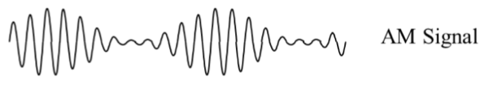

Note that in the AM signal only the amplitude of the wave changes = Amplitude Modulation.

Analog Signals and FM
Frequency modulation (FM) works in a similar way, except that instead of varying the amplitude of the carrier wave, we vary only the frequency of the carrier wave according to the value of the information signal.
Consider an information signal wave that looks like this:
Again this information signal has to be carried on a carrier wave with a higher frequency like this:
To carry the signal using frequency modulation, we will vary the frequency of the carrier wave according to the value of the information signal. So the FM signal that is transmitted looks like this:
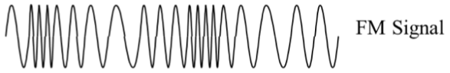
Note that in the FM signal only the frequency of the wave changes = Frequency Modulation.
Activity
You are now going to perform an activity that illustrates AM and FM modulation of analog signals.
The first signal you observe will be an analog AM modulation

The program is already loaded onto your computer. It should look something like this:
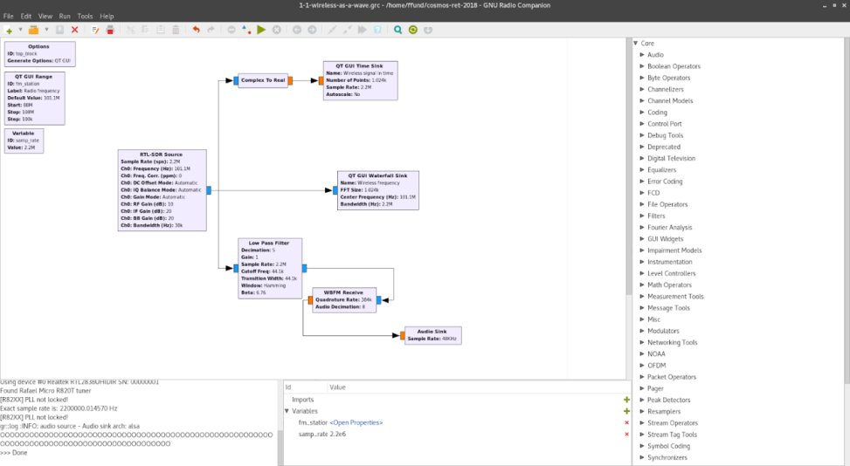
Turn the volume up on your computer, click the [ ►] to run the program. You will hear a song and a new window should open up and look something like this:
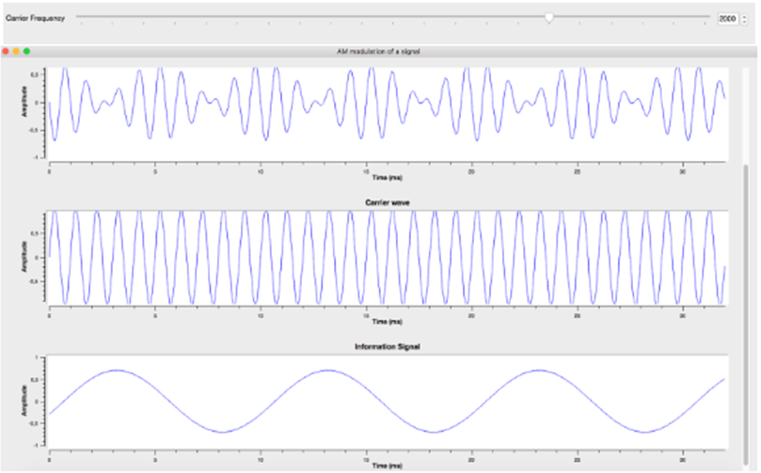
The bottom signal is the information signal. In the middle, we see the carrier signal, and on top, the AM modulated signal is plotted.
You can try to adjust the frequency of the carrier signal by moving the slider at the top of the graphs, and observe how the modulated signal is changing.

Listen to the song and describe the sound. Does it sound clear? Do you hear any disturbance in the sound? Observe and explain __________________________________________________________________________________________________________________________________________________________________________________________________________________________________________________________________________________________________________________________________________________________________________________________________________________________________________________________________________________________________________________________________________________________________________________________________________________________________________________________________________________________
Look at the bottom graph on the screen. Can you identify at what points in the song does the amplitude get really large? Is it when the song gets a loud note? Or when it gets a high or low note? Listen and look carefully and explain ________________________________________________________________________________________________________________________________________________________________________________________________________________________________________________________________________________________________________________________________________________________________________________________________________________________________________________________________________________________________________________________________________________________________________________________________________________
The second program you observe will be done in analog FM modulation.
Click the [ ►] to run the program. You will hear the song and a new window should open up similar to the one you saw before.
Listen to the song and describe the sound. Does it sound clear compared to the previous time? Do you hear any disturbance in the sound this time round? ________________________________________________________________________________________________________________________________________________________________________________________________________________________________________________________________________________________________________________________________________________________________________________________________________________________________________________________________________________________________________________________________________________________________________________________________________________________________________________________________________________________________________________________________________________________________________________________________________________________________________________________________________________________________________________________

Look at the bottom graph on the screen. Can you identify at what points in the song does the frequency change (i.e. gets really close together or spread out)? Is it when the song gets a loud note? Or when it gets a high or low note? Listen and look carefully and explain __________________________________________________________________________________________________________________________________________________________________________________________________________________________________________________________________________________________________________________________________________________________________________________________________________________________________________________________________________________________________________________________________________________________________________________________________________________________________________________________________________________________

