Student Name_________________________________ Class_________

Digital Wave Signals Lesson 5
An electromagnetic wave consists of an electric field and a magnetic field that travels through the air (matter) or space. If you can generate an electric field and a magnetic field, then you can create an electromagnetic wave. Electromagnetic waves travel at the speed of light: 299,792,458 m/s. They can travel long distances through air, through space and many materials.
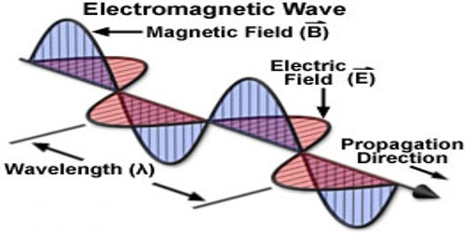
Whenever we use a wireless transmission to share information it is done with an electromagnetic wave. Any set of information can be an information signal. For example, the different temperatures through the day would be an information signal, and when you write a text, the letters of your message is an information signal. Informational signals are translated into electromagnetic waves and transmitted to other receivers somewhere else.

Information signals can be represented in two major forms: analog and digital.

Digital Signals
Digital signals are represented by specific values over time. Signals are in binary form (i.e. ‘0’ or ‘1’). The transmissions of digital signals are a lot less affected by noise compared to analog. That is why digital signals usually sound very clear and cleaner than analog signals. Digital signals require larger bandwidth than analog. Computers can only interpret and understand digital signals.

Examples in Real Life
Think of a regular thermometer and a digital thermometer. With the regular thermometer one would often not be certain as to the exact reading of the temperature. However, with the digital thermometer the reading is displayed with specific digits giving a definite reading.

Modulation
The process of transforming an information signal into an electromagnetic wave carrying this information is called modulation. When we modulate an information signal we vary one or more of three properties of a wave (amplitude, wavelength, phase) to represent the values of the information signal.

The 2 most common types of modulation are Amplitude Modulation (AM) and Frequency Modulation (FM). Both are used for analog signals and digital signals.

Digital Signals and AM
A computer can only process digital data, where all the information is in bit-streams of 1’s and 0’s (or, high voltage when the data is 1, and low voltage when the data is 0.)

So a digital information signal would look something like this:

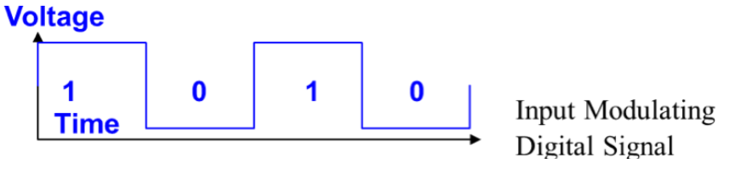

Once again this information signal has to be carried on a carrier wave with a higher frequency like this:

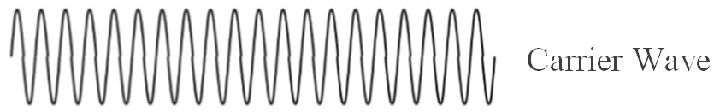

To carry the digital signal using amplitude modulation, we will vary only the amplitude of the carrier wave according to the value of the information signal. So the digital AM signal that is transmitted looks like this:
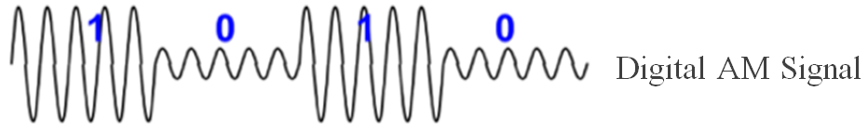
The shape of the digital AM signal can be represented as symbols, where
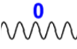
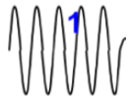 represents a value of 1, and represents a value of 0.
The computer can now interpret and understand the digital signals.

Digital Signals and FM

In FM modulation of a digital signal, we expect the signal to change only its frequency according to the information signal. Therefore, when the information signal has a “1” value the frequency of the FM modulated signal will be a bit higher than the carrier frequency, and when the information signal has a “0” value the frequency of the FM modulated signal will be a bit lower than the carrier frequency.

So to carry digital information signals using frequency modulation would look something like this:
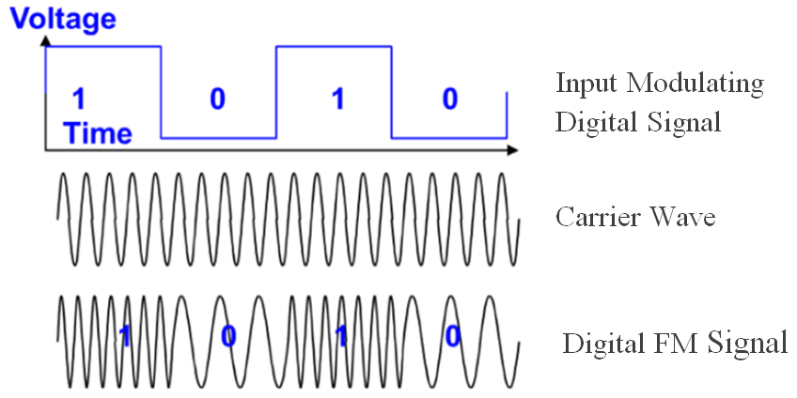

Again we can regard the different parts of the digital FM signal as representing the different values that the information signal can take: That is
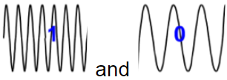 reoresents “1” and “0” respectively.
Here again the computer can now interpret and understand the digital signals.
You are now going to perform an activity that illustrates AM and FM modulation of digital signals.
The first signal will be done in digital AM modulation
The program is already loaded onto your computer. It should look something like this:
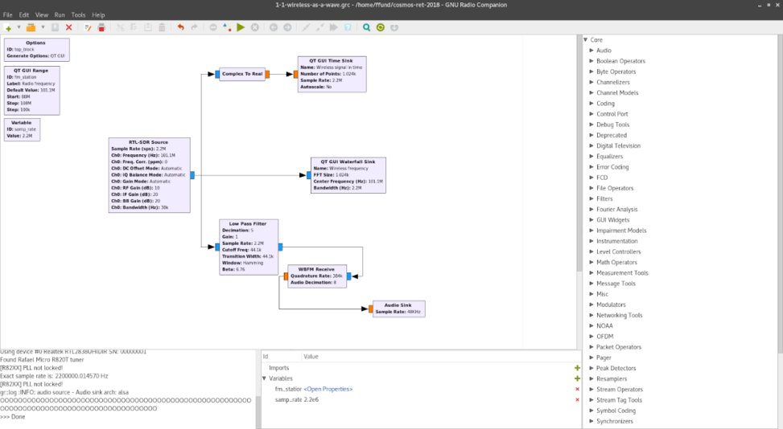
Turn the volume up on your computer, click the [ ►] to run the program. A new window should open up showing a graph and a video will start playing.
Look at the video and describe its quality. Does it look and sound clear? Does the picture quality have any distortions? Observe carefully and explain. ________________________________________________________________________________________________________________________________________________________________________________________________________________________________________________________________________________________________________________________________________________________________________________________________________________________________________________________________________________________________________________________________________________________________________________________________________________

The graphs on the screen should look something like this:
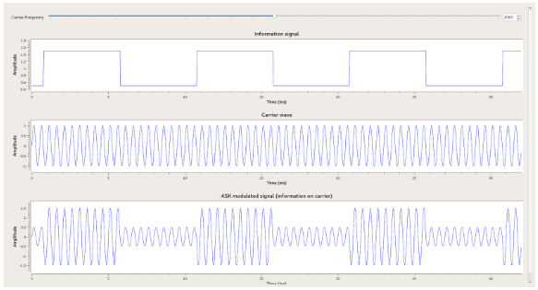

Now look at the bottom graph on the screen. Can you identify at what points in the video does the amplitude change (i.e. gets really large or really small)? Is it when the video changes to a new seen? Or when there is a lot of action in the screen? Observe carefully and explain ________________________________________________________________________________________________________________________________________________________________________________________________________________________________________________________________________________________________________________________________________________________________________________________________________________________________________________________________________________________________________________________________________________________________________________
The second segnal will be done in digital FM modulation.

Click the [ ►] to run the program. A new window should open up with a graph similar to the one you saw before and a video will start playing.

Again look at the video and describe its quality. Does it look and sound as clear as the one you previously saw? Does the picture quality have any distortions compared to the previous video? Observe carefully and explain. ________________________________________________________________________________________________________________________________________________________________________________________________________________________________________________________________________________________________________________________________________________________________________________________________________________________________________________________________________________________________________________________________________________________________________________

The graphs on the screen should look something like this:
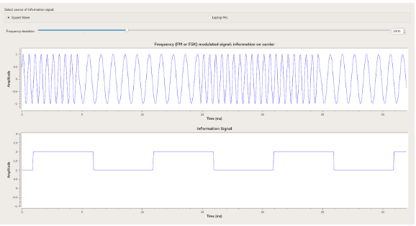
Can you identify at what points in the video does the frequency changes (i.e. gets really close together or spread out)? Is it when the video changes to a new seen? Or when there is a lot of action in the screen? Observe carefully and explain ________________________________________________________________________________________________________________________________________________________________________________________________________________________________________________________________________________________________________________________________________________________________________________________________________________________________________________________________________________________________________________________________________________________________________________________________________________

