PING ACTIVITY
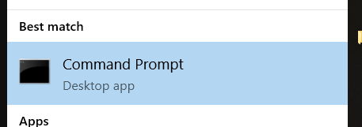
- OPEN COMMAND PROMPT:
  - From a Windows computer, click on the Windows key ⊞ Win

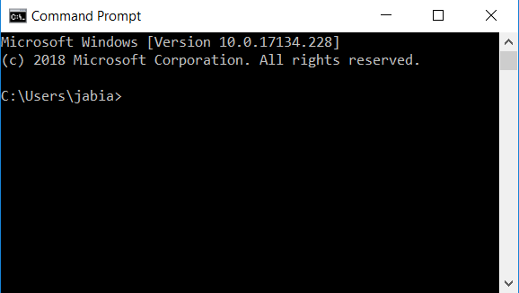
  - Type cmd to open the Command Prompt. You should see a new window pop up that looks like the following:

  - On the bottom line, you should see a location ( like C:\Users\hk1660) followed by a right angle bracket ( > )

- PING COMMAND
  - In the command line, you can type the name of a command after the right angle bracket ( > ).
  - We will use the ping command! To do so type the word ping, one space, then the address of where you want to go.

ping google.com

*Note: UPPERCASE and lowercase matter. Make sure you write the commands appropriately.

  - Who is sending the reply? _______._______._______._______
  - How long does it take google.com to reply (on average)? (Hint: Look for the Average number of milli-seconds) ________ ms

- PING TIMES
ping the following locations and record the times you get:

ping location | Time (ms)
espn.com
nytimes.com
172.217.12.142
104.193.88.123
ghana.gov.gh
kremlin.ru
juventus.com
A US site:
A non-US site:

- Reflection:
  - What difference did it make if did a ping using letters (like google.com) or numbers (172.217.12.142)?

  - What difference did it make if you did a ping on a US website vs a non-US website?

  - What do you think “ping” means?

Here is the official Microsoft page explaining the ping command: https://docs.microsoft.com/en-us/windows-server/administration/windows-commands/ping

