IP ADDRESS VISUALIZATION ACTIVITY

- CAPTURE SOME OF YOUR INTERNET TRAFFIC WITH WIRESHARK
  - Open the Wireshark program on your computer:

  - Click on the interface that matches your computer’s Wi-Fi card:
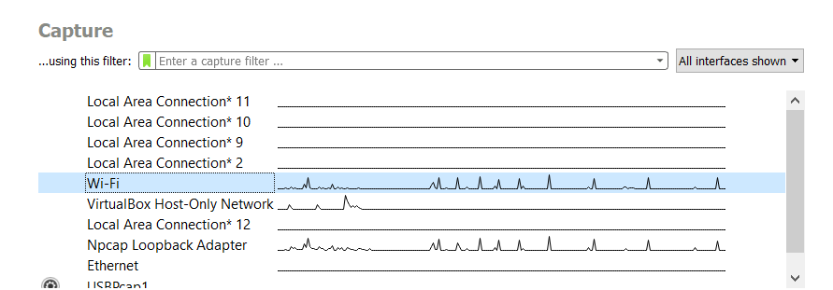
  - After 10 seconds, click on the icon to stop the capture.
  - We can export all of this data by clicking on File > Export Packet Dissections > As JSON ...
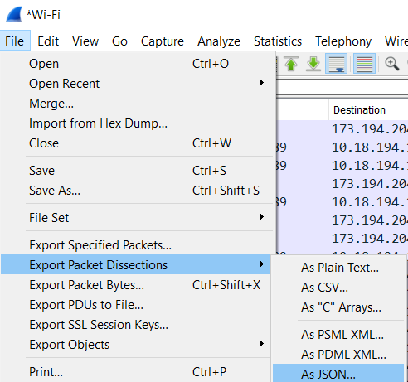
  - You can call this first file traffic1.json and save it to the Documents folder.

  - Note 1: You can control what type of data shows up by making your computer do some things that would require wifi (like surfing to some webpages).
  - Note 2: Another way to capture data about your traffic would be to write the following command in the Command Prompt:
"C:\Program Files\Wireshark\tshark.exe" -i 5 -a duration:15 -T json > traffic1.json

- VISUALIZE THE TRAFFIC
  - Go to the following webpage:
http://lapis-constrictor.glitch.me/
  - Enter the IP address of your computer.
(See below if you don’t know this number.)
  - Click on “Choose File”
  - Locate the .json file that you created previously.

How to find the IP address of your Computer:
- Open a Command Prompt by clicking ⊞ Win and typing cmd
- Type the command: ipconfig
- Find the wireless adapter that says “Wi-Fi”.
- You will see a “IPv4 Address” with 4 numbers: _____._____._____._____

- ANALYZE THE TRAFFIC

  - Which IP Address has the most number of packets? _____._____._____._____

  - Identify who owns the IP address. Use the command nslookup __.__.__.__ in the Command Prompt to see who that IP address belongs to: ________________________________________________________________

How to find the Name Server for an IP Address
- Open a Command Prompt by clicking ⊞ Win and typing cmd
- Type the command: nslookup __.__.__.__
(fill in the blanks with the IP address you want to look up)
- Example: nslookup 34.200.100.132

  - Which types of websites will generate the most traffic? Generate 3 different .json files that illustrate that you have tried generating different types of traffic.

Types of Traffic | Top IP Address | Top IP nameServer | # packets | dataRate
Example:  I was surfing on espn.com | 34.200.100.132 | . . . amazonaws.com | 4300 | 800 Mbps

- Reflection:
  - What conclusion can you make about the type of traffic you generated and the #of packets and datarate?

- Extension: IPv4 vs IPv6

  - IPv4 Address are made up of 4 numbers that range from 0-255. How many different IP addresses can you make with IPv4?
 | 192 . | 168 . | 0 . | 255
 | __________ . | __________ . | __________ . | __________
# options | 256 * | 256 * | 256 * | 256
 | 2^8 * | 2^8 * | 2^8 * | 2^8

  - IPv6 Addresses are made up of 32 numbers that range from 0-15. How many different IP address can you make with IPv6?
 | [ FE80 : | CD00 : | 0000 : | 0000 : | 0000 : | 0000 : | 211E : | 729C ]
 | _ _ _ _ : | _ _ _ _ : | _ _ _ _ : | _ _ _ _ : | _ _ _ _ : | _ _ _ _ : | _ _ _ _ : | _ _ _ _
# options | 16*16*16*16 | 16*16*16*16 | 16*16*16*16 | 16*16*16*16 | 16*16*16*16 | 16*16*16*16 | 16*16*16*16 | 16*16*16*16
 | 2^8 * | 2^8 * | 2^8 * | 2^8 * | 2^8 * | 2^8 * | 2^8 * | 2^8 *

  - Which is better: IPv4 or IPv6? Why?

