
Name:______________________ Class:_______________ Date:_______________
Match each vocabulary word with the correct definition
Vocabulary word | Definition
- Mean  - Measures of center  - Median  - Mode  - Qualitative data  - Quantitative measures  - Range  - Variability | - is computed by adding all of the numbers in the data together and dividing by the number of elements contained in the data set.  - The "Median" of a data set is dependant on whether the number of elements in the data set is odd or even. First reorder the data set from the smallest to the largest then if the number of elements are odd, then the Median is the element in the middle of the data set. If the number of elements are even, then the Median is the average of the two middle terms.  - The __________ for a data set is the element that occurs the most often. It is not uncommon for a data set to have more than one mode. This happens when two or more elements occur with equal frequency in the data set. A data set with two modes is called bimodal. A data set with three modes is called trimodal.  - The __________ for a data set is the difference between the largest value and the smallest value contained in the data set. First reorder the data set from smallest to largest then subtract the first element from the last element.Examples : Data Set = 2, 5, 9, 3, 5, 4, 7 Reordered = 2, 3, 4, 5, 5, 7, 9 Range = ( 9 - 2 ) = 7  - Data that can be quantified by counting or measuring.  - is descriptive information (it describes something)  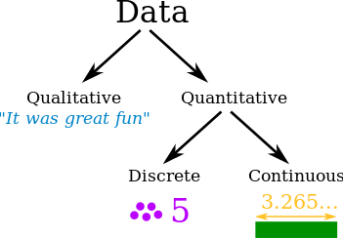  - describe a set of data by identifying the central position of the data set  - how spread out a group of data

