Traffic Flow for New York City
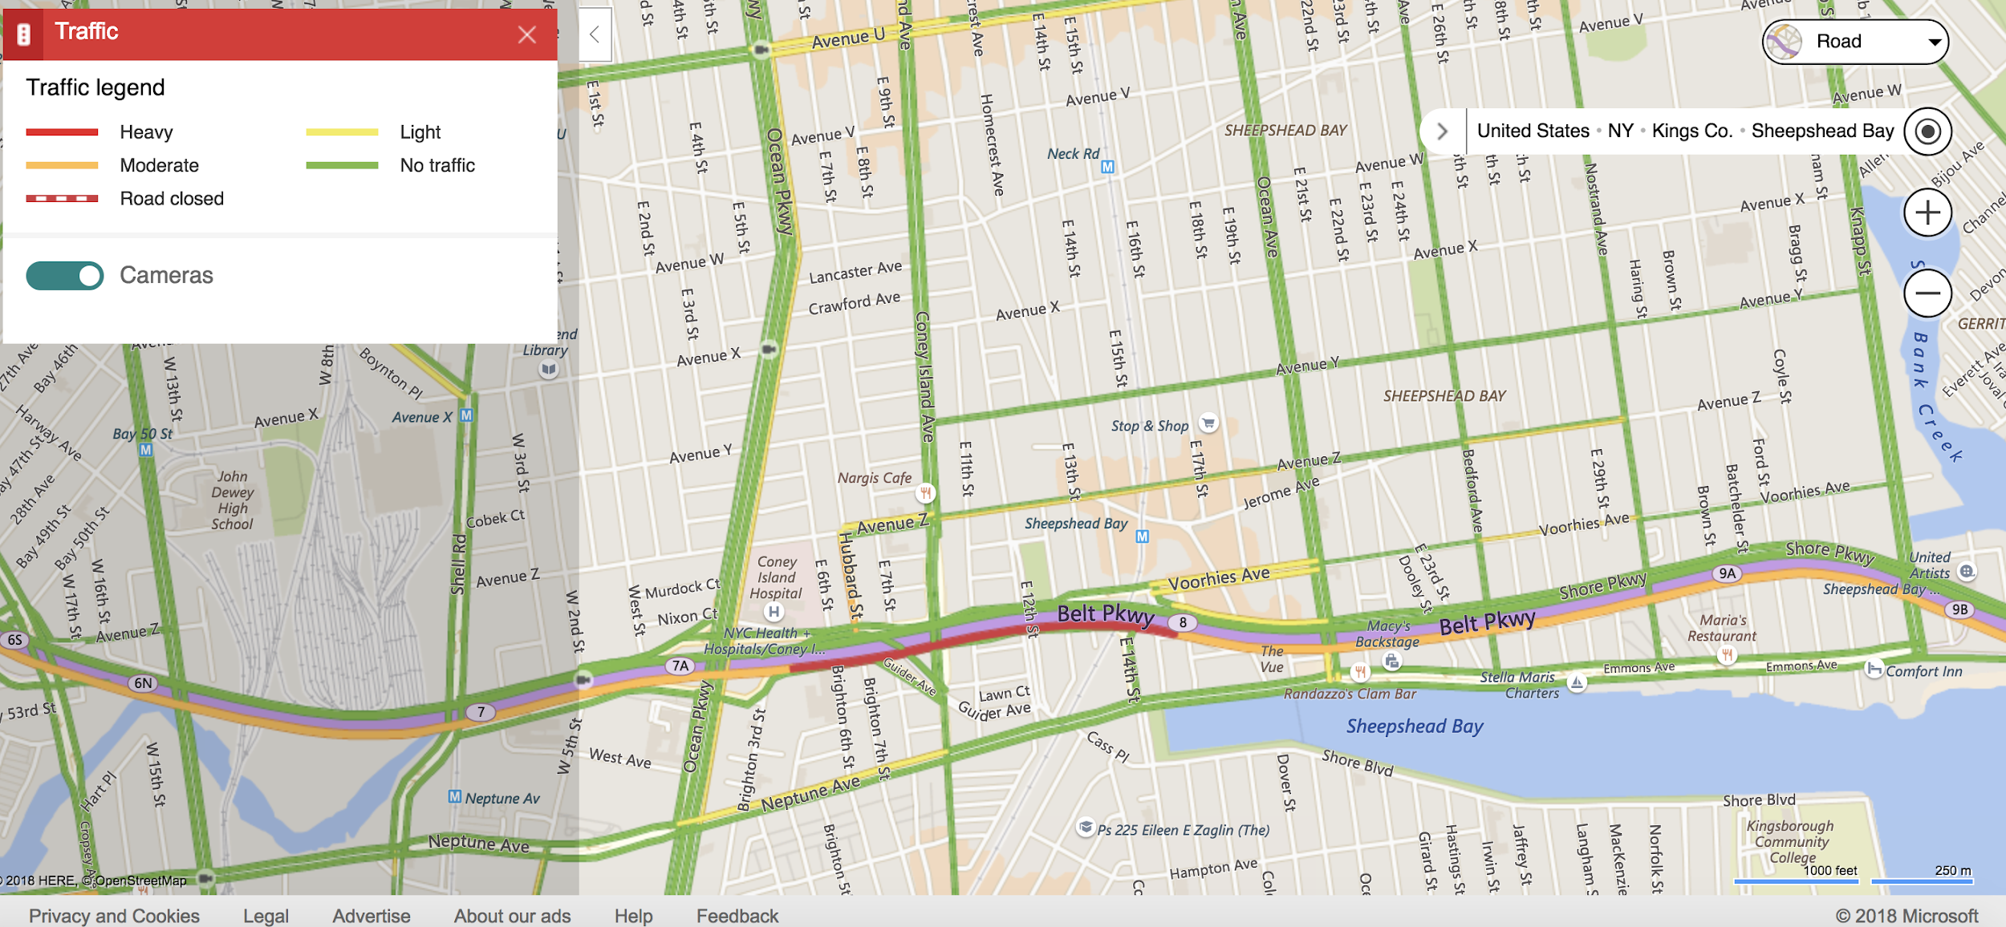
The document above could give you ideas where to perform the experiment for the traffic flow.
Click here to see the actual website.

See an example below on how you can use this website in choosing the areas for your research and experimentation.

