Proportionality and Rate of Change Using Bandwidth and Data Rate

Name: _________________________ Class: ____________ Date: ___________

Problem

How is data rate affected by the size of the bandwidth?

Hypothesis
What do you think will happen?
Write your hypothesis in the “If…(independent variable), then…(dependent variable)” format?

If __________________________________________________________________________________________________________________________________

then __________________________________________________________________________________________________________________________________.

Materials:
- COSMOS toolkit
- Post-it Chart Paper
- Markers
- Pencils
- Graph Paper
- Noise sensor
- Temperature Sensor
- Carbon Dioxide Sensor
- Computer

Procedure
Pre-lab preparations
- In your group, decide which job each person will have
  - Timer: __________________________________________________

  - Data Recorder/Program Runner: _______________________________________________________

  - Facilitator_______________________________________________

- Set-up the COSMOS Toolkit
- Check if the toolkit has all its complete set-up: antenna, SDR receiver and the monitor.
- Put the whole thing in a stable surface like a table.
- Have papers/graphic organizer ready for recording results.
- Make sure all graphic organizers are ready

- Discuss how you will orchestrate the whole process or create a system where you can perform the whole process within the allotted time.
- Perform the experiment when your teacher gives you the signal to start.

Day 1-Activity:

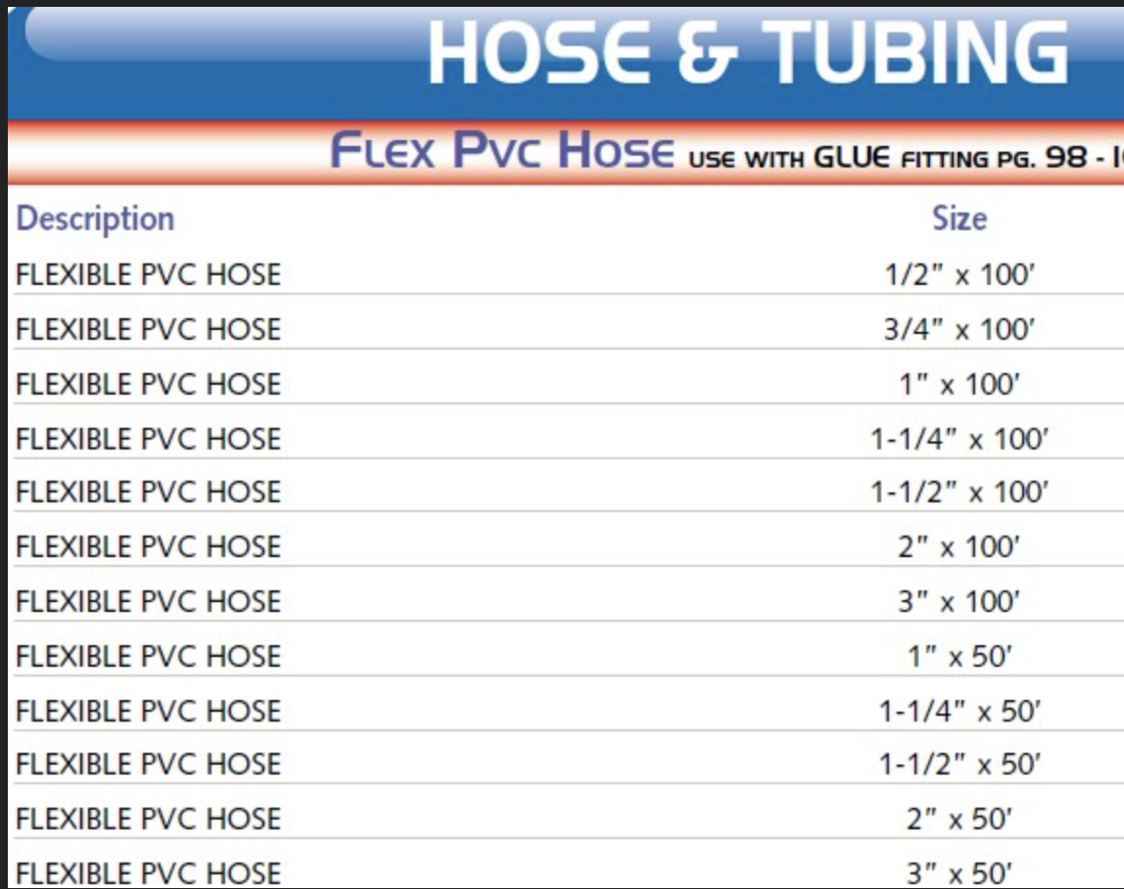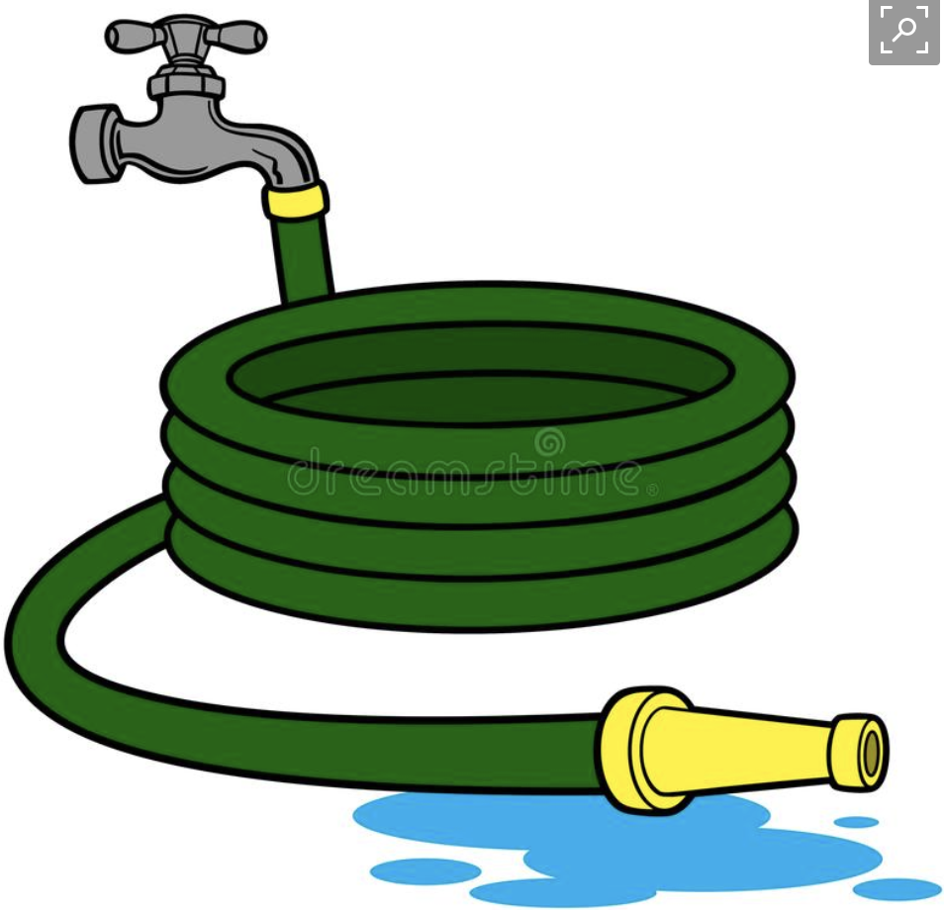

Using for example, the ½ inch, ¾ inch, 1 inch, 1 ¼ inches, 1 ½ inches diameter hose,
A typical 3- inch hose will have a flow rate of 7.34 gallons per minute. Using your knowledge on proportionality, determine the amount of water (in gallons) you can gather in a tank for each size of hose for a given time of 10 minutes.

Graphic Organizer/Table:

Hose Size ( in inches ) | Volume of Water ( in gallons )
½
¾
1
1 ¼
1 ½
3 | 7.34

Graph the following points on the Cartesian Plane and find out the slope and the y-intercept.

Determine the equation of the line and determine if the relationship between hose size is proportional or not to the volume of the water within 10 minutes.

Discuss your observations/ideas, thoughts, questions of this activity.

Day 2 - Experiment

Using the COSMOS Toolkit, the students will perform the experiment on the bandwidth and data rate. Students will remain in the same grouping as of Day 1 of this lesson.

Graphic Organizer/Table:

Bandwidth Size (kHz) | Data Rate ( bits per second )

Graph the following points on the Cartesian Plane and find out the slope and the y-intercept.

Determine the equation of the line and determine if the relationship between bandwidth and data rate are proportional or not.

Discuss your observations/ideas, thoughts, questions of this activity.

HELPFUL NOTES:

So far we have seen how we carry information on an electromagnetic wave, and how to visualize it in several different ways.

Now we introduce a new question: how much information can we put on an electromagnetic wave? Or, how quickly can a wave carry information?

To answer this question we need to formally introduce the idea of signal bandwidth. When looking at a signal in the frequency domain, we saw that the signal may not be only confined in a narrow range of frequencies, but may have energy on a wider set of frequencies. This range of frequencies “occupied” by a signal - in particular, the width of its range - is called its "bandwidth".

Viewing signal bandwidth
Consider the experiment in which we visualize the FM radio signal - we saw something like this:

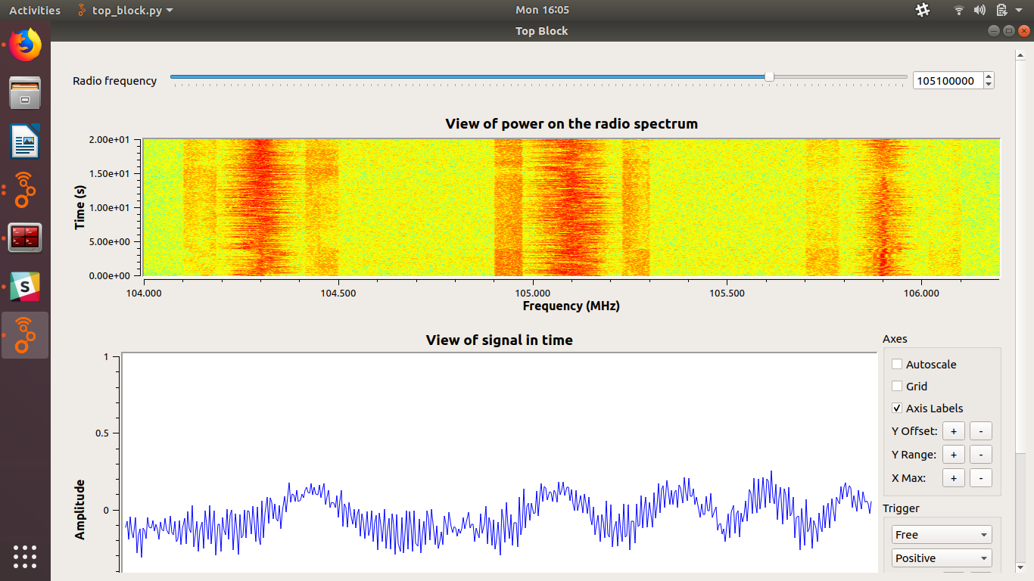
Each “tick” on the horizontal axis is 100 kHz. We can see that this signal occupies 400 kHz total - 200 kHz on either side of the center (carrier) frequency. This is its bandwidth.

Note that this does not depend on the carrier frequency (105.1 MHz in this case)!

But how does the signal bandwidth affect the rate at which information is sent over the air?

Signal bandwidth as a water hose ( Recall Day 1 Activity )
In order to better understand the relationship between the signal bandwidth and the rate at which information is passed over the air, let’s imagine the transmission as a water hose.

The information that we pass over it is like the water that flows inside the hose. The diameter of the hose restricts how quickly water can flow through it. The larger the diameter, the greater the capacity of the hose to carry water.

Similarly, the flow of information on a signal is limited by its bandwidth. The greater the bandwidth, the greater the capacity of the transmission. To send data more quickly, we need to increase the bandwidth.

Data rate is how much information we can send over the air in a given amount of time. It is usually measured in bits per second, meaning how many bits (a bit is a 0 or 1 value!) can be transmitted within a single second.

Note: sending vs. receiving
In this discussion, we consider only how fast the transmitter can send - other factors affect whether or not the receiver can correctly receive the signal.

Imagine one person speaking to another - if it is quiet in the room, and if they are close to one another, then the speaker can speak pretty quickly. On the other hand, if the room is noisy, or the person listening is far away, the person speaking may need to slow down and articulate more clearly. Otherwise the person listening may not hear them correctly.

A similar thing happens in wireless systems, where the transmitter may “slow down” in order to adapt to the environment and ensure correct reception. But in this lesson, we are not going to concern ourselves with the receiver. We are only concerned (for now) with how fast we can transmit information, without worrying about correct reception.

Relationship between data rate and bandwidth
The relationship between data rate and bandwidth is defined as follows: if all other factors are kept constant, the rate at which we can send data on an electromagnetic wave is proportional to the bandwidth it occupies.

In other words, if we double the signal bandwidth, the rate at which this signal can carry information will also be doubled!

Why do higher data rates need more bandwidth?
Why do higher data rates need more bandwidth? We'll get a little more technical to explain the physics behind it:

The higher the data rate, the more quickly the information signal changes.

An information signal has bandwidth proportional to the highest frequency in it. If the information signal changes from one bit to the next very quickly (high data rate), it has higher frequency components in it and occupies more bandwidth.

We saw this when we looked at an AM modulated signal in the frequency domain, and changed the information signal frequency - in the following images, we change the information frequency first to 200 Hz, then to 10 Hz:

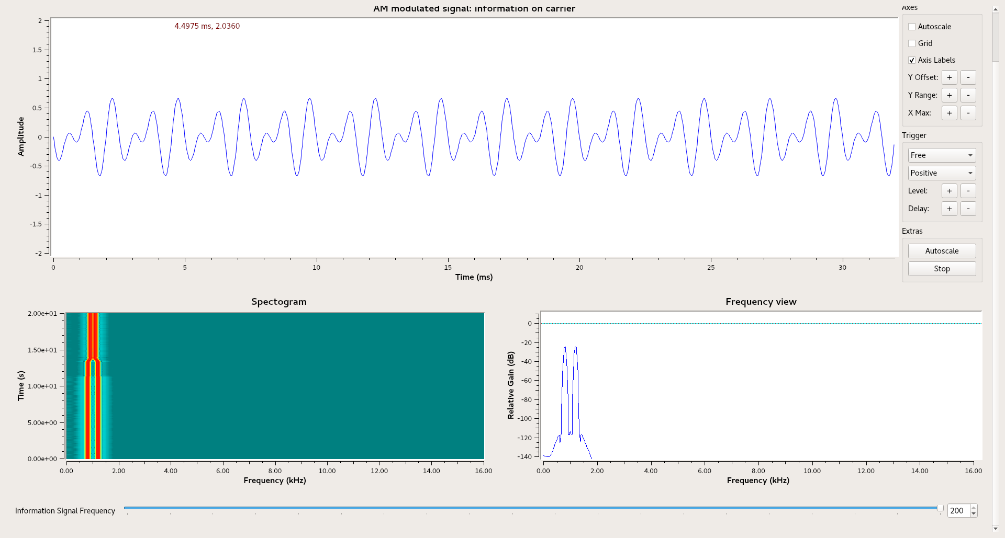
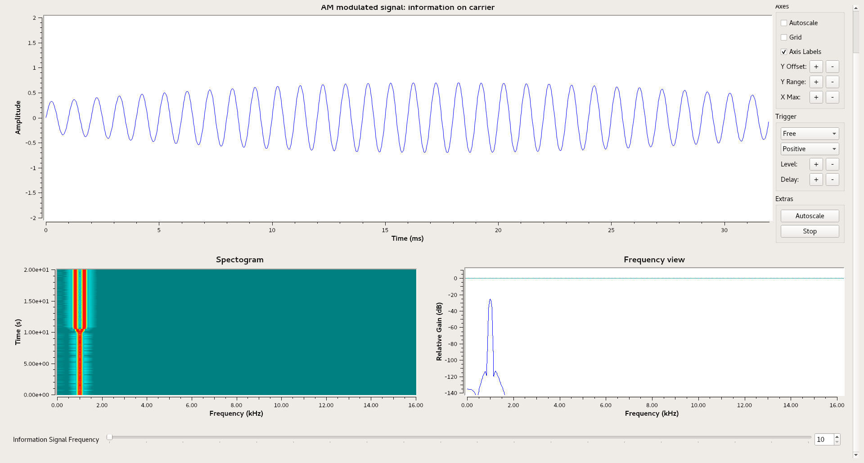

We can see that the higher the frequency of the information signal, the more bandwidth it occupies! (Note that the carrier frequency does not affect occupied bandwidth.) A similar effect occurs with other kinds of modulation as well, including digital modulation.

All else being constant - what else?
We mentioned that data rate is proportional to bandwidth, “all else being constant”. What else?

The main other factor affecting bandwidth is modulation - some types of modulation are more efficient at transmitting data. A more efficient modulation type can transmit more data in the same bandwidth.

Day 3
They will use this idea studying traffic flow or the amount of vehicles on certain huge highways with 6-8 lanes compared to small/narrow roads. They will research on the amount of pollution/carbon dioxide, level of noise and heat in areas like this.

Graphic Organizer/Table:

Street Name  or  Highway | Number of Lanes | Number Vehicles  ( per hour) | Carbon Dioxide Level | Temp. Level | Noise Level

Project ( assigned for 2-3 weeks )
Day 4 - 5 Start of the investigation
Students will investigate this phenomenon discussed on day 3 using the carbon dioxide, noise and temperature sensor. They will run this experiment at their chosen day and time depending on the group’s decision accomplishing this project for the designated time period.

Day 6-7 Sit down to organize, discuss findings, analyze and interpret data gathered, then make conclusions.
They will analyze the data gathered in these different real-world scenarios and discuss similarities & differences. Use appropriate graphs for the various information gathered on this experiment.

Project:
Students will present their discussions on Google Classroom with their powerpoint presentations of their findings, analysis, interpretations and conclusions of all the activities/experiments.

NOTE:
* 6th Grade can stop at Day 1 and Day 2 activity and experiment.
Then they will analyze the data gathered in these different real-world scenarios and discuss similarities & differences. Use appropriate graphs for the various information gathered on this experiment.
* 7th and 8th Grade it’s up to the teacher’s discretion up to which part of the lesson they can push their students depending on their diverse needs.

Analysis/Conclusions
Use the different discussions you had and the information gathered among yourselves and the research you did to simplify them/capsulize in the sample graphic organizer below. You can research other templates if you don’t like the one below.

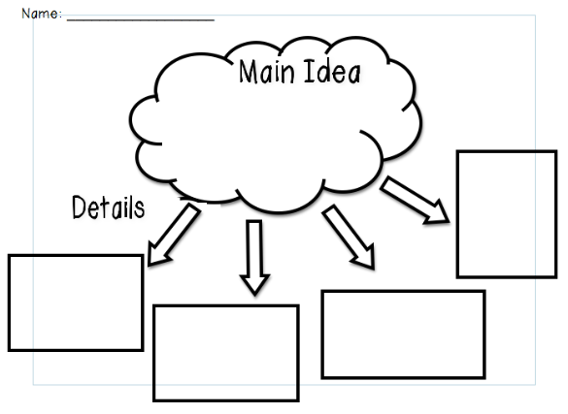
Here: Open this link to copy the template on a separate sheet.

Reflection
Think about your experiment!!
Your discussion must be detailed and include answers to the following questions:
- How did your data from Day 1, Day 2, and the Project the same?
- How is the data from Day 1, Day 2 and the Project different?
- What are some factors that could’ve led to differences between the two parts?
- Do you feel the data is valid (reliable and accurate)? Why or Why not?
- What were the sources of error in this experiment (factors that may have affected your results)? Explain.
- If you had the opportunity to redo the experiment, what changes would you make? How would you improve it? Explain.
- What new questions did the experiment generate? Explain.
- What did you learn from the experiment? Explain.

