COSMOS Experiment
Rate, Functions and Equations in the Real-World

NOTE:
* 6th Grade can stop at the table and give their observations, analysis and interpretations of both experiments.
* 7th , 8th, 9th Grade Extensions as the teacher decides up to which part they can push their students.

Grade 6-9
Topic:  Discover the rate/speed of a message, email or anything sent by finding the number of hops and internet providers it went through before reaching the destination. |  | Materials:  - COSMOS toolkit  - Post-it Chart Paper  - Markers  - Pencils  - Subway Map  - Google Map on Phone/Computer  - Globe  - Strings  - Push pins  - World Maps  - Graph Paper
Science & Engineering Practices (SEPs)  Obtaining, evaluating, and communicating information in 6-8 builds on K-5 and progresses to evaluating the merit and validity of ideas and methods. Integrate qualitative scientific and technical information in written text with that contained in media and visual displays to clarify claims and findings. (MS-PS4-3) | Disciplinary Core Ideas (DCIs)  PS4.C: Information Technologies and Instrumentation Digitized signals (sent as wave pulses) are a more reliable way to encode and transmit information. (MS-PS4-3)  Each sense receptor responds to different inputs (electromagnetic, mechanical, chemical), transmitting them as signals that travel along nerve cells to the brain. (MS-LS1-8)  (NYSED) Plants respond to stimuli such as gravity (geotropism) and light (phototropism). (MS-LS1-8) | Crosscutting Concepts (CCs)  Patterns Graphs and charts can be used to identify patterns in data. (MS-PS4- 1)  Structure and Function Structures can be designed to serve particular functions by taking into account properties of different materials, and how materials can be shaped and used. (MS-PS4-2)  Structures can be designed to serve particular functions. (MS-PS4-3)  Connections to Engineering, Technology, and Applications of Science Influence of Science, Engineering, and Technology on Society and the Natural World Technologies extend the measurement, exploration, modeling, and computational capacity of scientific investigations. (MS-PS4-3)
Math Common Core Standards:

6th Grade:

6.RP.A.1-Understand the concept of a ratio and use ratio language to describe a ratio relationship between two quantities.

6.RP.A.3-Use ratio and rate reasoning to solve real-world and mathematical problems, e.g., by reasoning about tables of equivalent ratios, tape diagrams, double number line diagrams, or equations.

6.EE.9-Use variables to represent two quantities in a real-world problem that change in relationship to one another; write an equation to express one quantity, thought of as the dependent variable, in terms of the other quantity, thought of as the independent variable.

7th Grade:
7.RP.2.a, b, c, d -Recognize and represent proportional relationships between quantities.

7.EE.B.4-Use variables to represent quantities in a real-world or mathematical problem, and construct simple equations and inequalities to solve problems by reasoning about the quantities.

8th Grade:

8.EE.B.5-Graph proportional relationships, interpreting the unit rate as the slope of the graph. Compare two different proportional relationships represented in different ways.

8.EE.B.6-Use similar triangles to explain why the slope m is the same between any two distinct points on a non-vertical line in the coordinate plane; derive the equation y = mx for a line through the origin and the equation y = mx + b for a line intercepting the vertical axis at b.

8.F.B.2
Compare properties of two functions each represented in a different way (algebraically, graphically, numerically in tables, or by verbal descriptions).
8.F.B.4
Construct a function to model a linear relationship between two quantities.
8.F.B.5
Describe qualitatively the functional relationship between two quantities by analyzing a graph (e.g., where the function is increasing or decreasing, linear or nonlinear).

Algebra 1

HSA.CED.A.2
Create equations in two or more variables to represent relationships between quantities; graph equations on coordinate axes with labels and scales.

HSA.REI.D.10
Understand that the graph of an equation in two variables is the set of all its solutions plotted in the coordinate plane, often forming a curve (which could be a line).

S-ID.7 Interpret the slope (rate of change) and the intercept (constant term) of a linear model in the context of the data. ★

S-ID.8 Compute (using technology) and interpret the correlation coefficient of a linear fit.★ S-ID.9 Distinguish between correlation and causation.

Essential Question:
How fast does a message travel over the network before reaching its destination?

Learning Target | Today I am doing an experiment on how fast a message travel on the network whether it’s an email, a text message, a research on a webpage, a picture, or a audio/video call, instagram, facebook message, etc.  I will find the number of hops and internet providers will take before it reaches its destination.
Engage | - Opener: Tell me how you get to school in the morning.  - Discuss how we would travel to one of the following locations from our school: (teachers’ choice: Bronx Zoo, Roosevelt Island, Brooklyn Aquarium, Yankee Stadium, Schomburg Museum, Hall of Science, World Fair, Snug Harbor, or Staten Island Zoo via NYC Transit (Subway).  - Use Google Maps and a subway map to track our commute.  - We’ll look at rate: number of stops/time traveled (minutes)  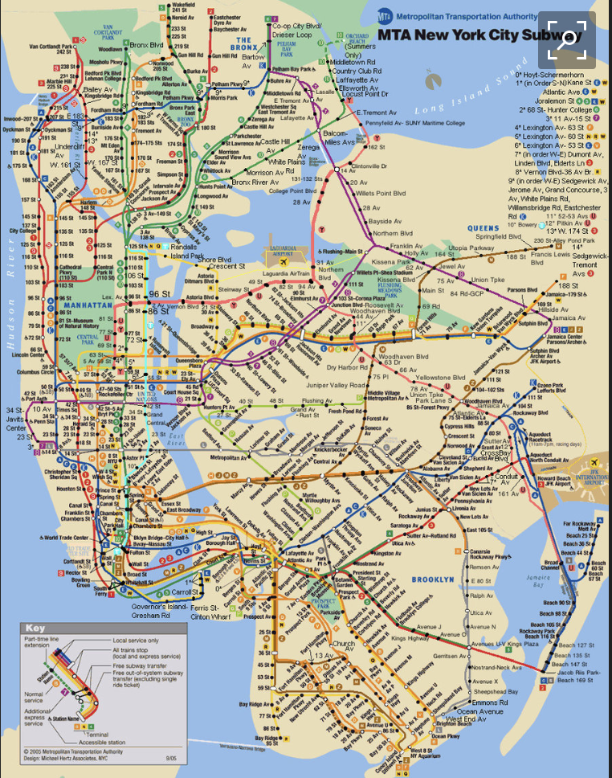  - Students will perform the Experiment/Activity:  - Number of stops/time  - Students engage in a see, think, wonder of the signal screenshot.  - See: What do you notice?  - Think: What do you think your noticing mean?  - Wonder: Create a question that you would like to explore further based on your noticings and conjectures?  - Discuss with the students their conjectures and wonderings.
Explore | - Explain experiment procedure  - Day 1  - Students will discuss about hops on a train as they travel from one train to another before reaching their destination.  -They will look a map of a subway and trace their hops.  -In similar way, they will be shown a sample of a routing map on how a message is sent and discuss how different or similar the two maps are.  - Day 2  -The students will perform the actual experiment where they will use the COSMOS toolkit to determine the number of hops and internet providers when they make a research on a webpage, send a text message, send a message as an email, on Facebook, instagram, messenger, or make a audio call/video call, Facetime, etc.
Explain | - In small groups, the students will discuss their observations, their findings, questions, multiple representations of the results and trends based on the data.  - In a gallery walk, students will present all of their data and make connections across the different groups. They can use this space to discuss results and trends across the groups. *Peer evaluations*
Extend | - Discuss the relevance of this project to Science, Geography, Technology and Mathematics.  - As a Project, students will plot the exact locations of these internet provider locations and hops of a message before it reaches its destination. They will use push pins to show the exact location on the world map and use colored strings to connect them.  - 8th and 9th Grade could determine the longitudinal and latitudinal locations of these hops and internet providers and tabulate data on a table and graph them
Evaluate | Find out if the students were able to accomplish the main goal/learning target/essential questions posted before the experiment started.  Post the projects on the walls and the class will discuss the finding and the results of their experiments after the gallery walk they did on this activity on day 2.  Feedbacks/questions will be entertained regarding the whole experiment and what they found out.
Differentiation | Students will be grouped heterogeneously. Each group will be expected to meet the same standards.  Graphic organizers and vocabulary sheets will be available to students to use.

