Effect of Noise in the Communication System

Problem

How does the Transmit Amplitude and the Noise Amplitude and affect the Constellation Diagram?

How do we know if we have transmitted enough power in order to be heard over the noise in any phenomenon?

Hypothesis
What do you think will happen?
Write your hypothesis in the “If…(independent variable), then…(dependent variable)” format?

If __________________________________________________________________________________________________________________________________

then __________________________________________________________________________________________________________________________________

Materials:
COSMOS toolkit
- Post-it Chart Paper
- Markers
- Pencils
- Graph Paper
- Noise sensor

Procedure
Pre-lab preparations
- In your group, decide which job each person will have
  - Timer: __________________________________________________

  - Data Recorder/Program Runner: _______________________________________________________

  - Facilitator________________________________________________

- Set-up the COSMOS Toolkit
- Check if the toolkit has all its complete set-up: antenna, SDR receiver and the monitor.
- Put the whole thing in a stable surface like a table.
- Have papers/graphic organizer ready for recording results.

- Discuss how you will orchestrate the whole process or create a system where you can perform the whole process within the allotted time.
- Perform the experiment when your teacher gives you the signal to start.

Day 1-Activity:

- Brainstorm among themselves for about 10-15 minutes about the different types of noise that they encounter in real-life/daily activities around them.

- They will classify these noise into different types based on the sources.

- They will research as a group and find out from different internet sources of
their classifications match with theirs or if they discovered something new
that they do not know before.

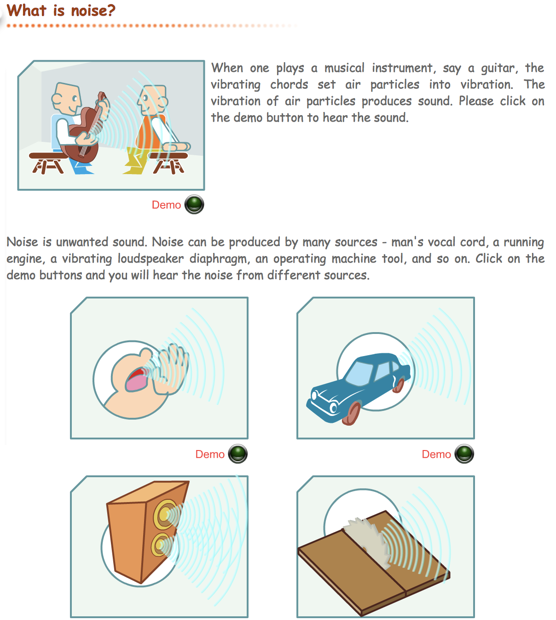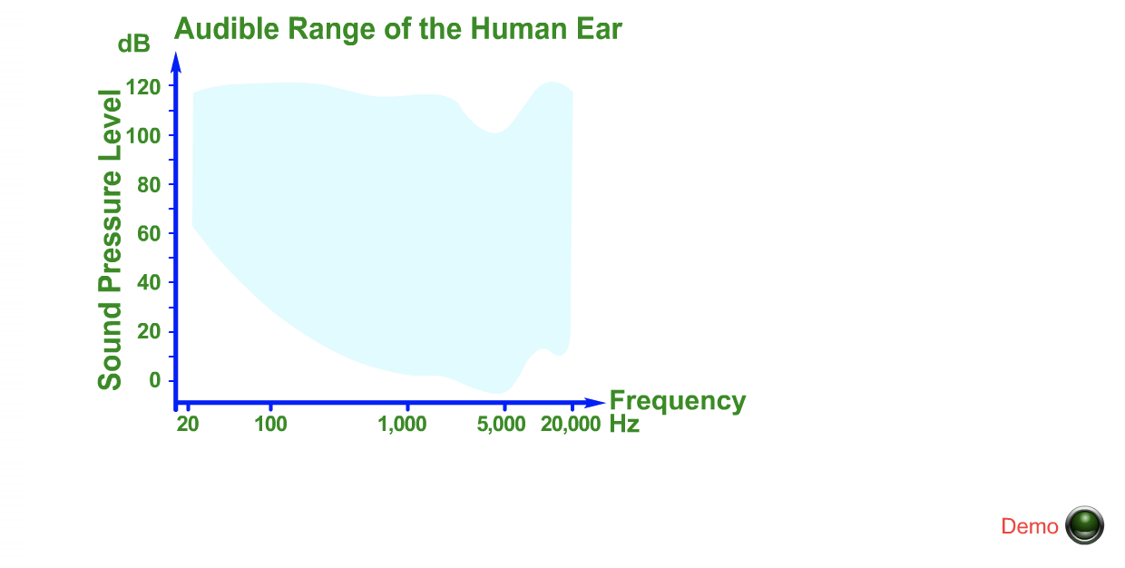

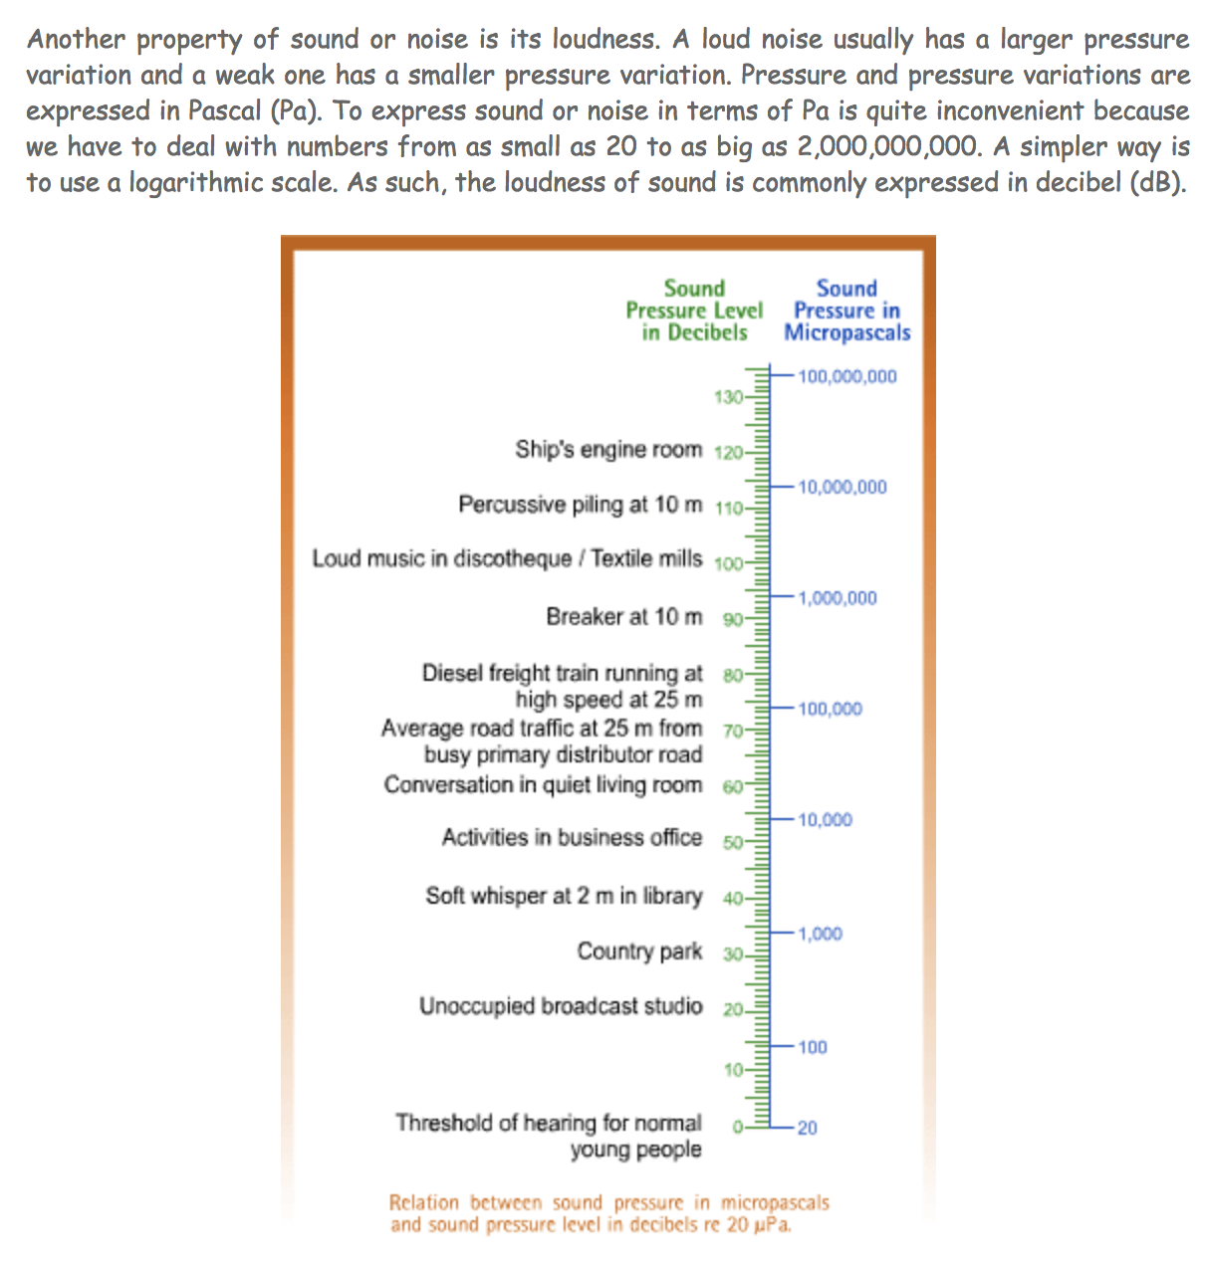
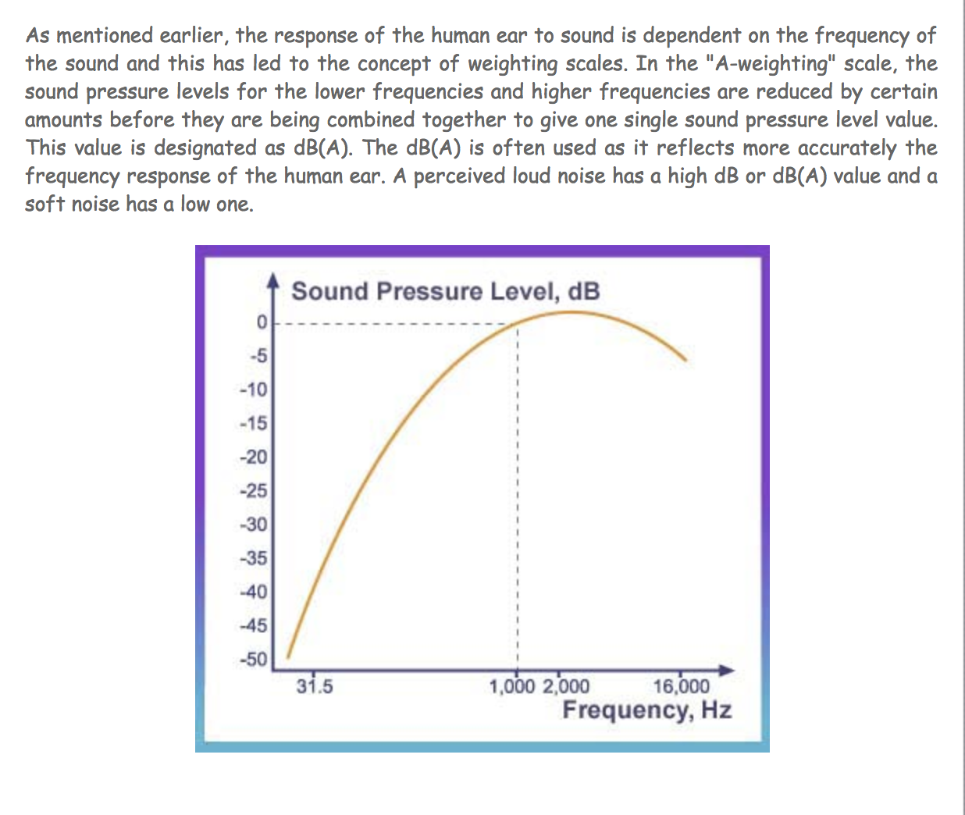

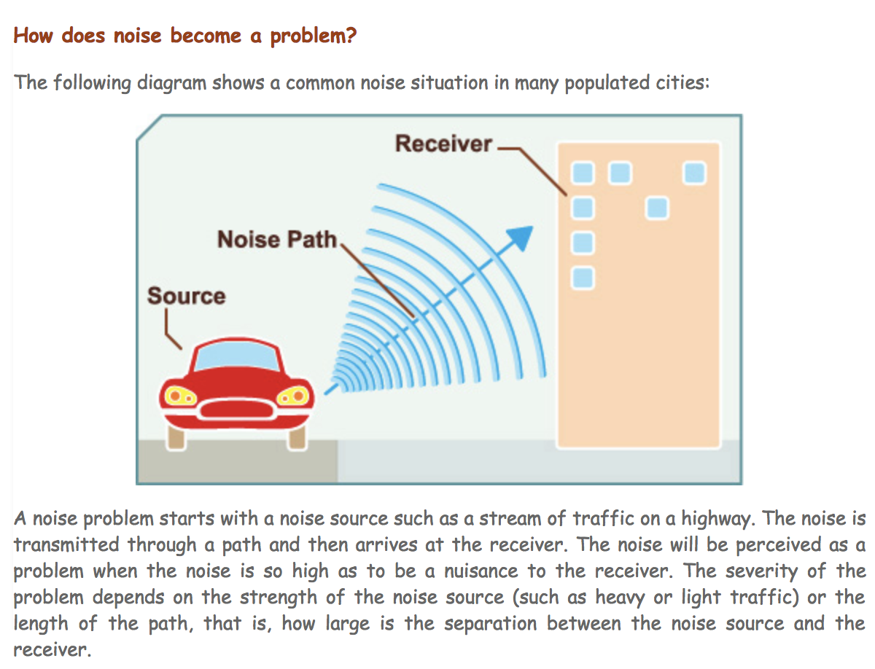

Some helpful resources for your reference:
https://www.epd.gov.hk/epd/noise_education/young/eng_young_html/m2/m2.html

https://www.slideshare.net/bridgetfinnegan/how-to-reduce-noise-in-your-communica

Question:
What can you do to help reduce noise? Explain and justify your thinking.

4. To wrap up the session, they will share the discussion they had and what they find out in their research about the different types of noise and sources that they have came from.
5. Each team will be given 2-3 minutes each.

Day 2 Activity:

Use GNU Radio to observe the effect of noise in a communication system

Question:
How is noise detected in the communication system besides knowing that it transmit sound waves to the receiver?

- Download the file “1-6-psk-noise.grc” from Google Drive and open it in GNU Radio Companion.
- When you press the green “play” icon to start the application, you’ll see a window like this:

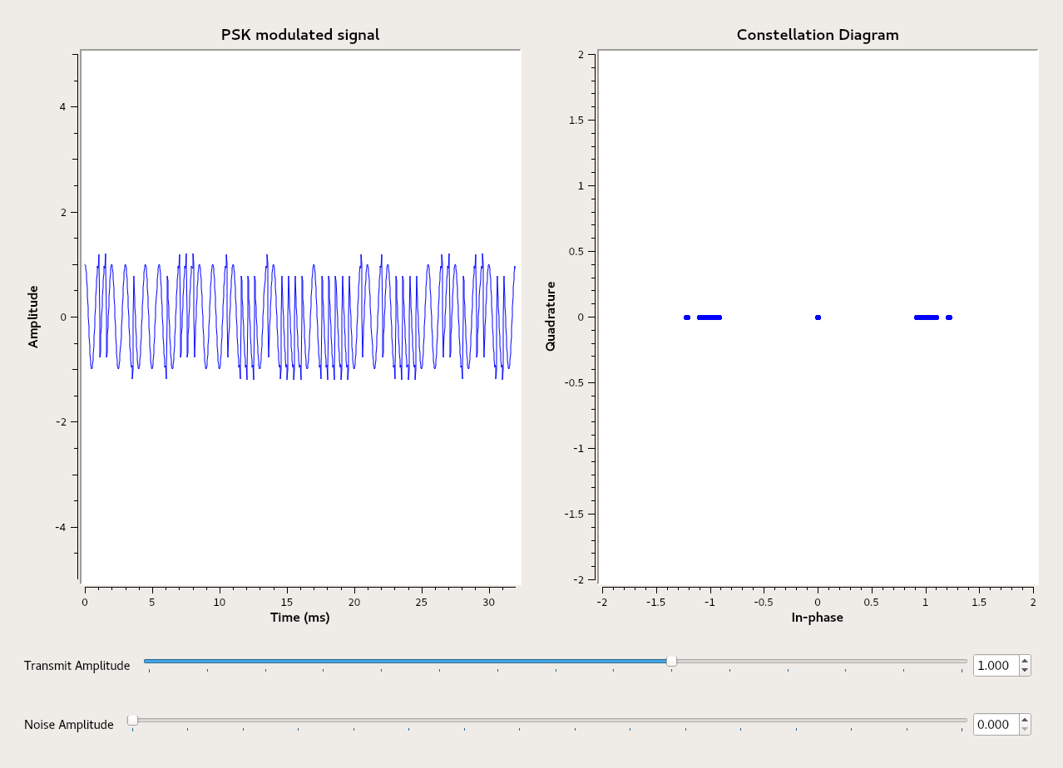

3. On the right, we see a PSK-modulated signal (it’s a square wave that is modulated into two PSK symbols, with phase offset of 0 and 180 degrees representing the bits 1 and 0). On the left, we see a constellation diagram of the received symbols - they appear at two locations on a circle around the origin, at 0 and 180, as expected.

4. On the bottom there is a slider you can use to adjust the power at which you transmit. Move the slider and see what happens to both the time-domain view and the constellation. Share your screenshots and observations on the graph.

5. Below this is a slider you can use to adjust the power of the noise in the system. Move the system and see what happens. Can you see how noise makes it difficult to decide how to interpret the received symbols? Share your screenshots and observations in the graph.

Questions:
- What happens if the noise power is just below the transmit power?

b. What happens if you leave the noise amplitude fixed at some small value (say 0.2) and change the signal transmit amplitude. Can you overcome the noise by transmitting more powerfully? Comment on Google Classroom.

6. Now, we’ll see the effect of increasing the number of symbols. Stop the simulation from running (X the window) so that you are looking at your GNU Radio flowgraph again. Double-click on the box called “PSK mod’ and change the value of “Number of constellation” from 2 to 4.
7. Press the green button again to run the application with the new settings. (You may be prompted to save the changes you’ve made. Make sure to save them a location such as the Desktop.)
8. You’ll see a new constellation of received symbols, with 4 points on it. Repeat your experiments with noise and signal amplitude again. Then, change your constellation size to 16 and repeat.

9. Below are four screenshots of this experiment, with noise amplitude of 0.4 and signal amplitude of 1.0, for four different constellation sizes.

- ) 2 symbols:
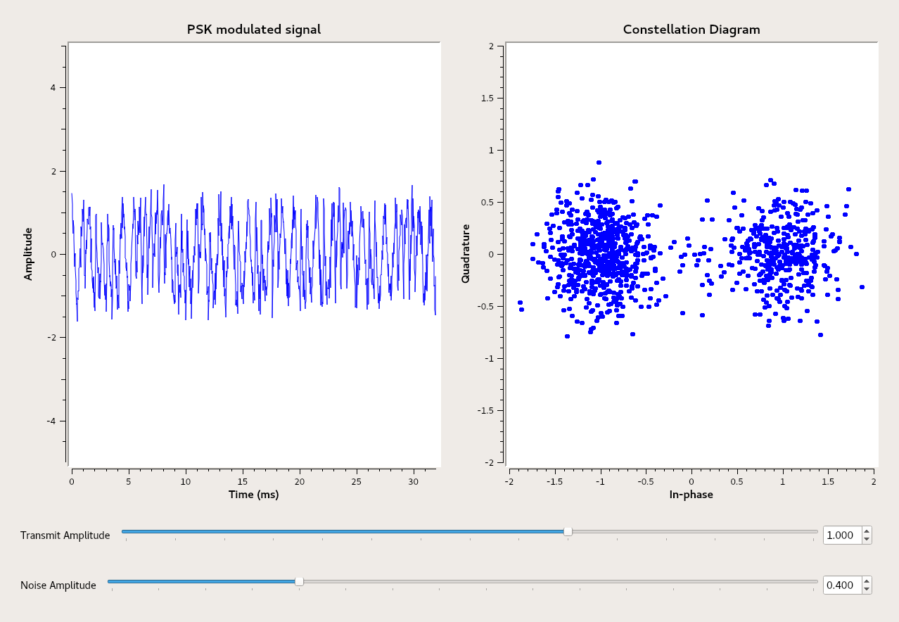
B.) 4 symbols:
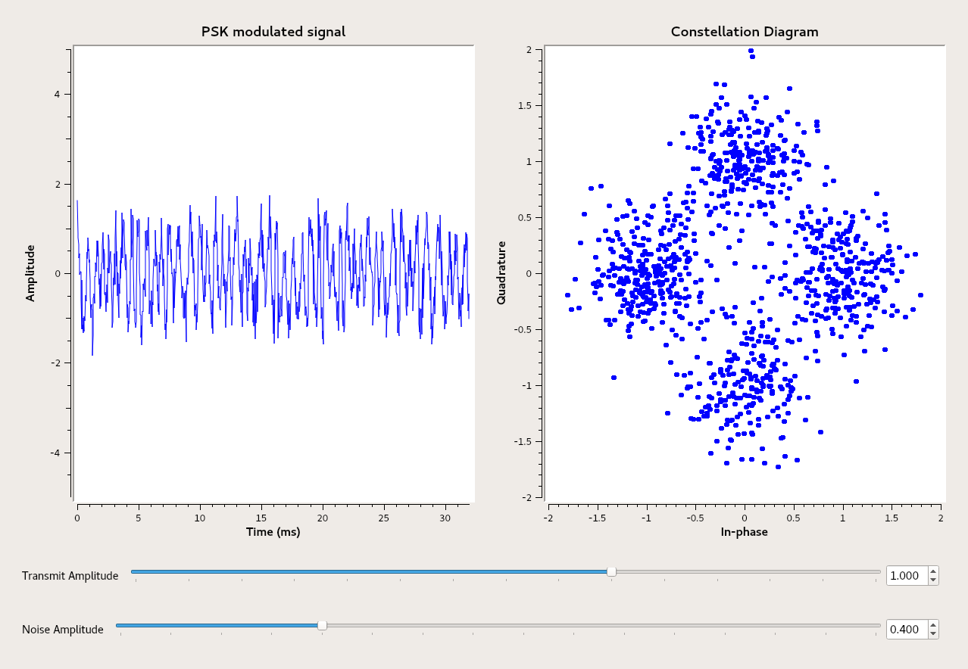
C. 16 symbols:
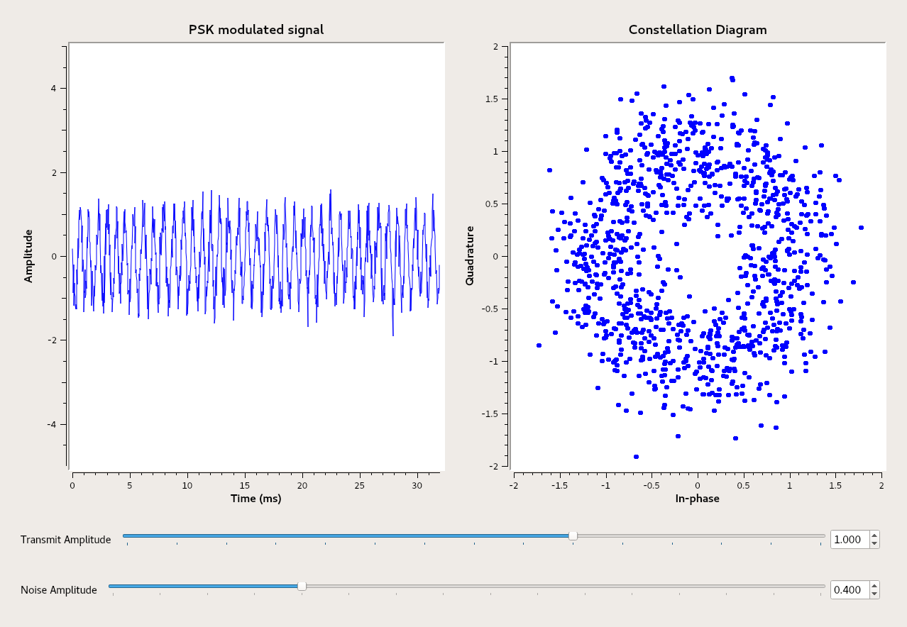

See if you can create similar screenshots yourself.

Questions:
- Can you comment on the effect of noise on different constellations?
- How is the number of symbol levels related to its resilience to noise? Explain why?
- Can you suggest one advantage and one disadvantage to transmitting with a large number of constellation points (symbols) vs a small number? Justify your answers.

NOTE:
* 6th Grade can stop at the table and give their observations, analysis and interpretations of both experiments.
* 7th , 8th, 9th Grade Extensions as the teacher decides up to which part they can push their students.

Analysis/Conclusions
Use the different discussions you had and the information gathered among yourselves and the research you did to simplify them/capsulize in the sample graphic organizer below.

Day 1-

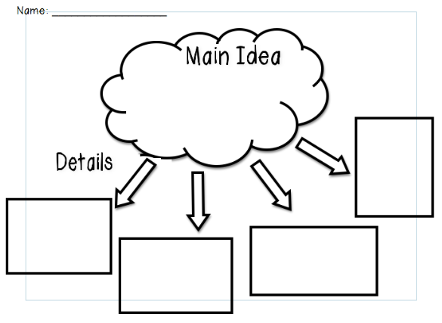
Here: Open this link to use other templates

Questions:

- What do you notice about the data you collected?
______________________________________________________________________________________________________________________________________________________________________________________

- Based on you graphic organizer, what can you conclude about the different environmental or other sources of noise around you/us?
_________________________________________________________________________________________________________________________________________________________________________________________________________________________________________________________________________________________________________________

3) What steps can you do to prevent unnecessary noise?
How can we be heard and be able to function over the noise around us?
Is this possible? Explain and Justify your thinking based on your discussion
today.

Day 2 -Graph
- Draw the picture or insert a screenshot of the PSK Modulated Signal & the Constellation Diagram as you move the slider of both the Transmit amplitude and the noise amplitude.
- Observe the changes

Two Symbols:

 | Transmit Signal Amplitude ( in Voltage )
Noise Amplitude  (in Voltage | 0 | .1 | .2 | .3 | .4 | .5 | .6 | .7 | .8 | .9 | 1.0
0
.1
.2
.3
.4
.5
.6
.7
.8
.9
1.0

Four Symbols:

 | Transmit Signal Amplitude ( in Voltage )
 | 0 | .1 | .2 | .3 | .4 | .5 | .6 | .7 | .8 | .9 | 1.0
Noise Amplitude
(in Voltage)
0
.1
.2
.3
.4
.5
.6
.7
.8
.9
1.0

Sixteen Symbols:

 | Transmit Signal Amplitude ( in Voltage )
 | 0 | .1 | .2 | .3 | .4 | .5 | .6 | .7 | .8 | .9 | 1.0
Noise Amplitude
(in Voltage)
0
.1
.2
.3
.4
.5
.6
.7
.8
.9
1.0

- What do you notice about the data you collected? Using two symbols, four symbols? Sixteen symbols?
______________________________________________________________________________________________________________________________________________________________________________________
__________________________________________________________________________________________________________________________
__________________________________________________________________________________________________________________________

- Based on your data shown on the graph, what conclusion can you derive from it. Discuss and explain your observations.
_________________________________________________________________________________________________________________________________________________________________________________________________________________________________________________________________________________________________________________
__________________________________________________________________________________________________________________________
__________________________________________________________________________________________________________________________

Project -Activity

Make an experiment using the noise sensor and test the different areas and take note of their noise levels.

Examples:
-cafeteria
-mall
-house
-playground/park
-street
-subway
- water running from the faucet
-classroom
-music class during performance

Create a bar graph comparing the noise level of these places using the noise sensor.

Reflection
Think about your experiment!!
Your discussion must be detailed and include answers to the following questions:
- How did your data from Day 1 and Day 2 the same?
- How is the data from Day 1 and Day 2 different?
- What are some factors that could’ve led to differences between the two parts?
- Do you feel the data is valid (reliable and accurate)? Why or Why not?
- What were the sources of error in this experiment (factors that may have affected your results)? Explain.
- If you had the opportunity to redo the experiment, what changes would you make? How would you improve it? Explain.
- What new questions did the experiment generate? Explain.
- What did you learn from the experiment? Explain.

