Student Name__________________________________ Class_________
Waves Lesson 1
In this Activity we will observe and visualize FM radio signals (waves) in the air around us. To do this we will attach some small devices to our computer: an antenna that will generate an electrical current matching the electromagnetic wave that hit it, and a small circuit that will transform the signals (wave) it receives into digital format for the computer to read and display. The equipment you will use looks something like this:
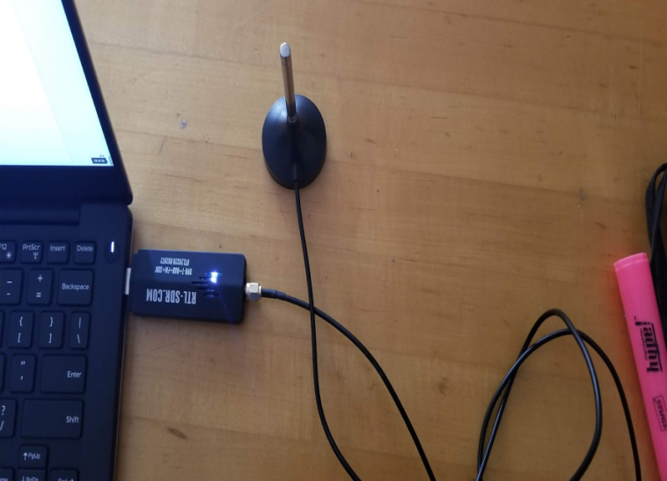
On your computer you will see a screen that looks like this:
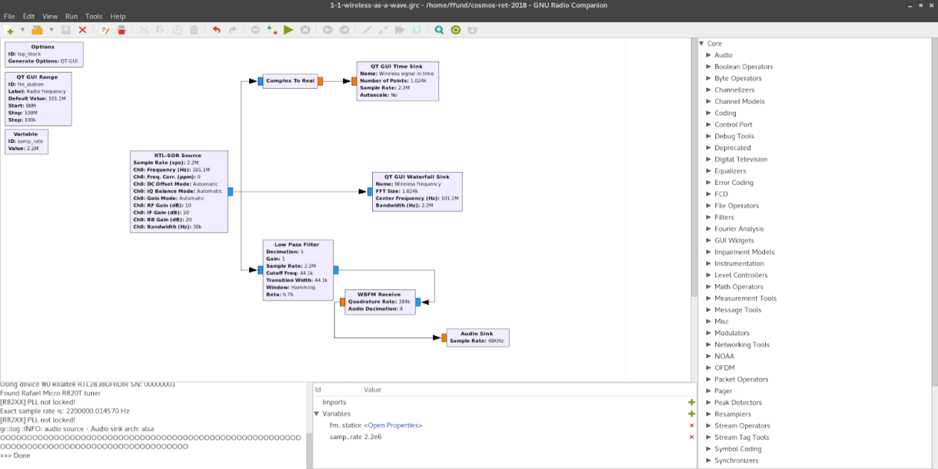
Near the top of the menu bar there is a series of icons. One of them looks like this: ►. Click on it and a new window will open up to display the flow graph. The graph should look something like this:
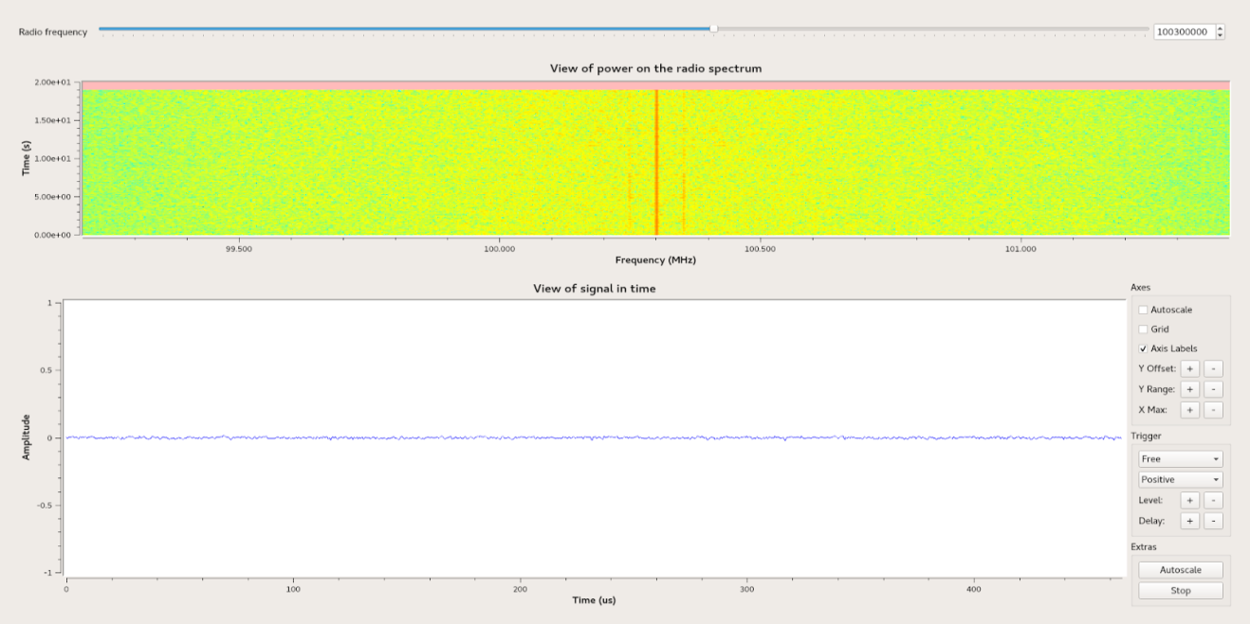
At the top of the window you will see a slider which you can move to change the frequency the radio is tuned to. FM radio stations may be on a frequency from 87.5 MHz to 108 MHz, at intervals of 0.2 MHz (e.g. 87.5 MHz, 87.7 MHz, 87.9 MHz, 88.1 MHz…).
If a radio frequency is transmitting with a lot of power it will appear more red on the graph display as shown below:
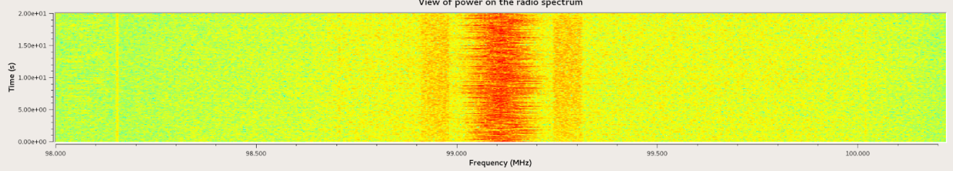
If the power of the transmission is lower the display will be less red and thinner, and if there is no power on a channel it will look like this:
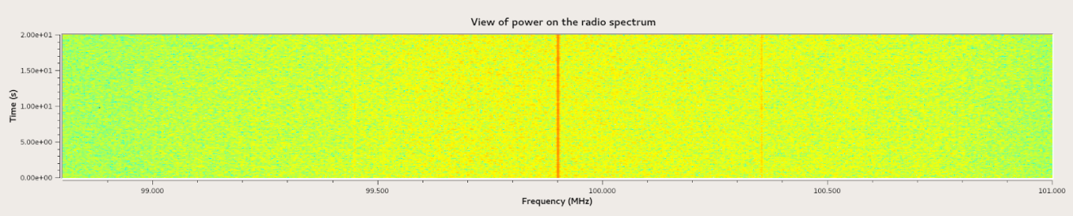
Sometimes you may see that there is no power at the frequency you are tuned to, but there is power nearby at other frequencies, like this:
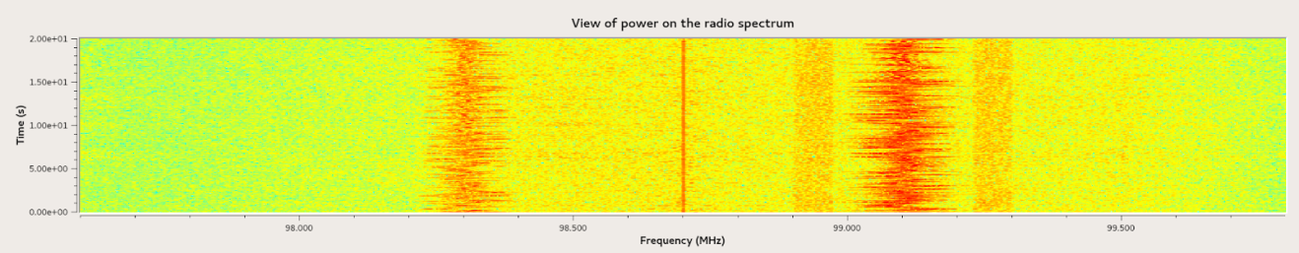
The level of redness and the width of the display indicate how much power is in the transmission.
Finally, in the bottom window you will see a view of the signal level over time. In this view, there is nothing, just noise:
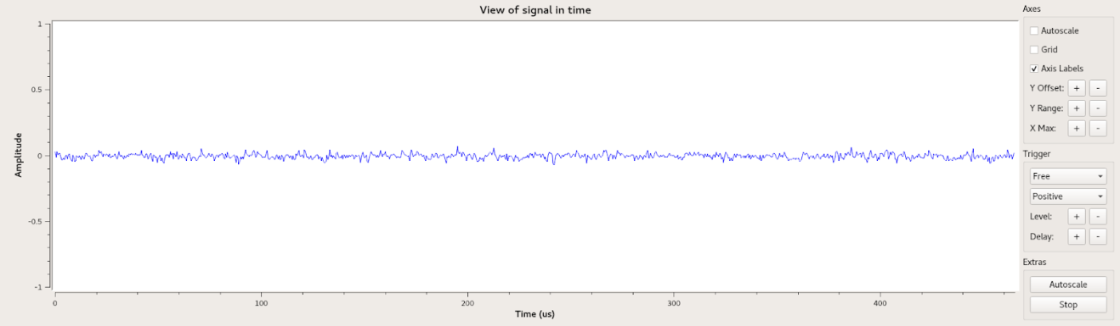
When the frequency signal has a lot of power it will look something like this:
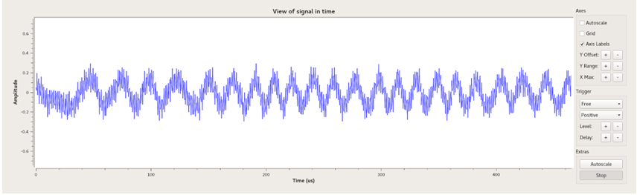
Note that the graph is a plot of amplitude vs time. Recall that the amplitude of a wave tells you how much power (energy) the wave carries.

TASK
On your computer turn the volume up to a high level. Move the slider from left to right across the screen and tune to a FM frequency with a lot of power. Try to find as many frequencies as you can that shows good power. Record the frequencies in the space below
- Frequency_____________________MHz
- Frequency_____________________MHz
- Frequency_____________________MHz
- Frequency_____________________MHz
- Frequency_____________________MHz
- Frequency_____________________MHz
- Frequency_____________________MHz
- Frequency_____________________MHz
- Frequency_____________________MHz
- Frequency_____________________MHz

- Which frequency has the highest power? _______________MHz
- Explain how you know this ___________________________________________________________________________________________________________________________________________________________________________
What is the relationship between the power of a wave and the amplitude of a wave? Explain ____________________________________________________________________________________________________________________________________________________________________________________________________________________________________________________________________________________________________________________________________________________________________________________________________________________________________________________________________________________________________________________________________________________________

