Student Name___________________________________ Class________

Bandwidth Lesson 6
Bandwidth is the range of frequencies “occupied” by a signal – in particular, the width of the range of frequencies. Recall, that when looking at a signal in the frequency domain, we saw that the signal may not be only confined in a narrow range of frequencies, but may have energy on a wider set of frequencies. See below:

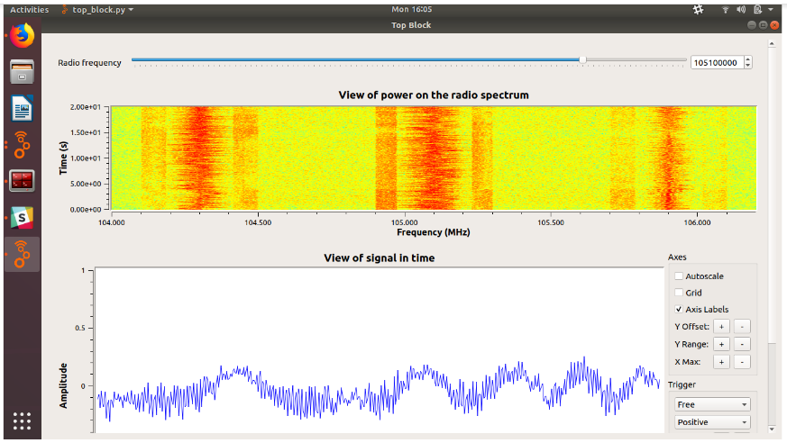

Let us take a closer look at the top graph showing the “Power of the radio spectrum”

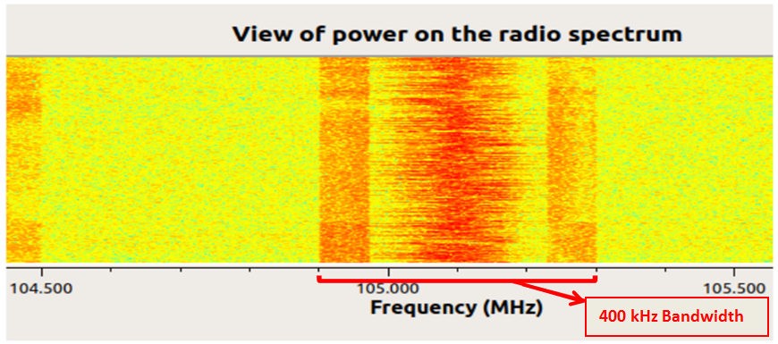

Each “point” on the frequency axis is 100 kHz. We can see that this signal occupies 400 kHz in total. This is its bandwidth.

Think of bandwidth as a garden hose we use to water our flower garden. The greater the diameter of the garden hose, the greater amount of water the garden hose can carry. Similarly, the flow of information data is affected by its bandwidth. The greater the bandwidth, the faster we can send data and the more data we can send.

Data rate is how much information we can send over the air in a given amount of time. It is usually measured in bits per second, (a bit is a 0 or 1 value!) meaning how many bits can be transmitted within a single second.

The relationship between data rate and bandwidth is defined as follows: if all other factors are kept constant, the rate at which we can send data on an electromagnetic wave is proportional to the bandwidth it occupies. In other words, if we double the signal bandwidth, the rate at which this signal can carry information will also be doubled!

We are now going to perform an activity to see the relationship between data rate and bandwidth. We’ll send information using wave signals with different bandwidths, and see how long it takes to send a fixed amount of data.

Activity
We are going to use our COSMOS Technology Toolkit for this experiment. We will transmit a fixed amount of data at 2 different data rates and then measure the bandwidth and the time taken to complete the transmission.

In our first transmission we will be sending 5 megabytes (MB) of data and transmitting at a rate of 0.5 MB per second [This is ½ million bytes per sec.].

The materials and equipment are set up on your desks. Follow the instructions from your teacher and carry out your first transmission.

Look at the graph and measure how much bandwidth this uses up. Record it below

Bandwidth: _________________________MHz

When the transmission is over look at the bottom left of the screen and see “real”. This tells the “real time” (in minutes & seconds) it took to transmit this data. Record the real time below

Real time: __________________________

Now let’s send a second signal, but this time we are going to change the transmission rate. This time we are going to transmit at a rate of 2 MB per second [This is 2 million bytes per sec.].
The materials and equipment are set up on your desks. Follow the instructions from your teacher and carry out your second transmission.

Look at the graph and measure how much bandwidth this uses up. Record it below

Bandwidth: _________________________MHz

When the transmission is over look at the bottom left of the screen and see “real”. This tells the “real time” (in minutes & seconds) it took to transmit this data. Record the real time below

Real time: __________________________

Questions

How was the bandwidth affected when we changed the transmission rate?
______________________________________________________________________________________________________________________________________________________________________________________________________________________________

Compare the time it took to transmit both signals and state which was faster.
______________________________________________________________________________________________________________________________________________________________________________________________________________________________

Based on everything you just did what is the relationship between the data transmission rate and bandwidth?
____________________________________________________________________________________________________________________________________________________________________________________________________________________________________________________________________________________________________________________________________________________________________________________________________________________________________________________________

