Student Name__________________________________ Class_________

Transmission of Waves Lesson 2
In this activity we are going to transmit information on a wave wirelessly and see if we are able to receive (capture) the signal with our antenna and visualize it on our computer. To do this we will use the ADALM-PLUTO Transceiver or “Pluto” for short. A transceiver is a device with both a transmitter and a receiver in a single package. It can both transmit and receive information alternately. The term applies to wireless communication devices such as cellular telephones, handheld two-way radios (walkie-talkies), and mobile two-way radios. The PLUTO will be connected to your computer looking something like this:
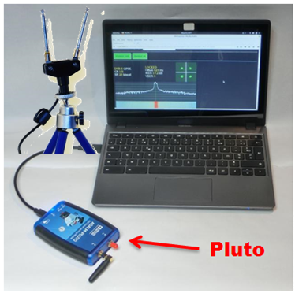

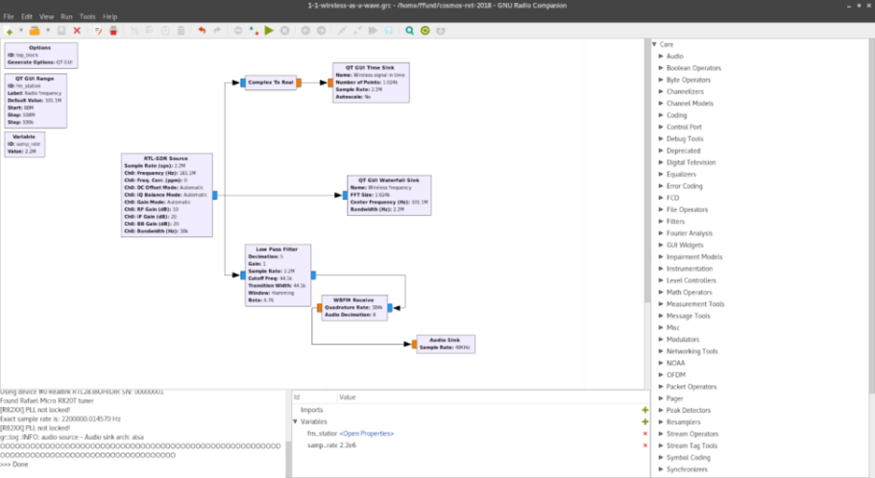
In this experiment your teacher will transmit a wave signal from his computer and the class will see if they can receive (capture) the signal and visualize it on their computer. The program is already loaded onto your computer. It should look something like this:

Turn the volume up on your computer, click the [ ►] to run the program and get ready to receive the transmission.
Your teacher will tell you when the signal has been transmitted.
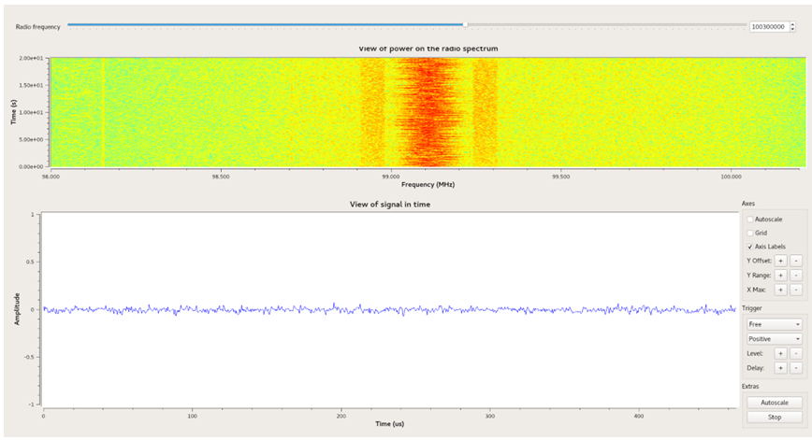
When you have received the signal your screen should look something like this:
Indicate to your teacher when you have received the signal.
TASK
- Look at the graph on your computer showing the signal you just received. What is its frequency? Record it below
Frequency ___________________________MHz
- Can you tell how much power the signal has from the graph? Explain how much power the signal you received has and explain why you say this ________________________________________________________________________________________________________________________________________________________________________________________________________________________________________________________________________________________________________________________________________________________________________________________________________________________________________________________________________________________________________________________________
Describe the relationship between the power of a wave and the amplitude of a wave? ________________________________________________________________________________________________________________________________________________________________________________________________________________________________________________________________________________________________________________________________________________________________________________________________________________________________________________________________

